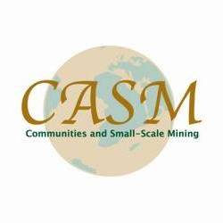

Communities and Small Scale Mining

5th Annual General Meeting and Learning Event

September 18-24, 2005
Salvador de Bahia, Brazil

MEETING SUMMARY AND REPORT

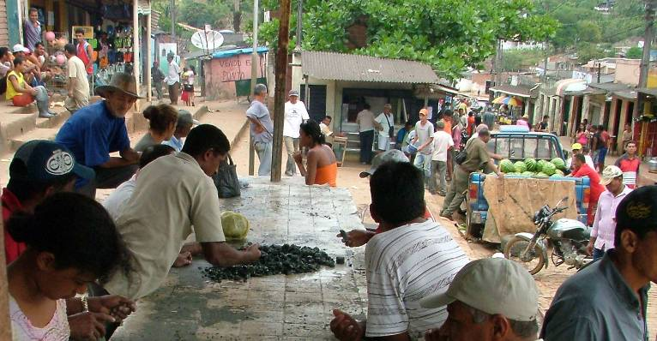

“Building sustainable communities
through artisanal and small-scale mining”

Acknowledgements

CASM extends its sincere appreciation for the support received for this event from:

- The United Kingdom’s Department for International Development (DFID),
- The World Bank,
- The staff of the Companhia Baiana de Pesquisa Mineral (CBPM),
- The staff of Centro de Tecnologia Mineral (CETEM)
- The companies, organizations and projects contributing and sharing their experience and expertise during the presentations.

The CASM Secretariat also wishes to express its gratitude to those companies and organizations in Brazil who assisted and hosted the conference venue and the site visits for the post-conference field trip to Jacobina, Campo Formosa, Carnaiba and Ourolandia.

Further special thanks is given to the many speakers and workshop leaders whose time and energy made the learning events both challenging and rewarding.

Finally, CASM acknowledges the various contributions of Jeffrey Davidson, Amelia Williams, Estelle Levine and Veronika Kohler of CASM without whose hard work the event would not have been as successful, or as enjoyable.

Table of Contents

Acknowledgements 2
Table of Contents 3
Executive Summary of Annual Meeting 5
Registration and pre-conference CASM Business Meeting 8
Program of pre-conference CASM Business Meeting 8
Technical Program, Day One 9
Program of morning session 9
Remarks and presentations of morning session: Opening Ceremony 9
John Hobbs, UK Department for International Development, Chairman of CASM: 9
Claudio Scliar, Federal Secretary of Geology and Mines, Ministry of Mines, Brazil 10
José Luiz Pérez Garrido, Secretary of Industry, Commerce and Mining of Bahia, Brazil 10
H.E. Esperança Laurinda Bias, Minister of Mines, Mozambique 10
Linus Adie, on behalf of H.E. Oby Ezekwesili, Minister of Solid Minerals, Nigeria 11
Gotthard Walser, CASM Secretariat, Mining Department, World Bank Group 11
Group Photograph 12
Program of afternoon session 13
Presentations of afternoon session 13
Miguel Antonio Cedraz Neri (DNPM): History of ASM in Brazil and challenges ahead 13
Adalberto Figueiredo Ribeiro (COMIN-Bahia government): The evolution of the government response to managing garimpagem 14
Ildegardo Rosa Santos (OCEB): Perspectives of the Bahia Mining Cooperatives 14
Walter Lins Arcoverde (Federal University of Rio Janeiro): Perspectives from communities affected by ASM - Indigenous Issues 15
Prof. Marjorie C. Nolasco: Environmental Transformations by Diamond Miners: the historical case of Lavras Diamantinas in the Chapada Diamantina National Park, Bahia, and actual perspectives by mining communities 15
Jose Maria de Souza: Malaria, Mercury and ASM 16
Gildasio Amorim Carvalho, Carnaibas: Perspectives from Local Garimpeiros I 16
Claudionor Costa: Perspectives from Local Garimpeiros II 16
Dorivado Junior of Coritambe: Perspectives from Local Garimpeiros III 17
Representatives of COOAMAC: Perspectives from Local Garimpeiros IV 17
Day Two of Technical Program 18
Program of presentations of morning session 18
Presentations of morning session 18
Lucie Phillips (International Business Initiatives): Development from the bottom up: Community-based jobs and growth 18
Thuthukani Mtshali (Mintek): Integrated Rural Development through ASM: South African case study 19
Gabriela Factor: Mainstreaming Gender in ASM: Women Mining in Bolivia 19
Mike Burns (Council for Scientific and Industrial Research, South Africa): Managing Natural Resources for Sustainability in ASM Communities 19
Program of morning session breakout groups 21
Notes from morning breakout groups 21
Group: Community-driven development and Integrated Rural Development 21
Group: Building on the Foundation: Advancing Gender Equity in ASM 22
Group: Managing Natural resources for sustainability in ASM communities 23
Program of afternoon session presentations 24
Presentations of afternoon session 24
Cesar Mosquera (ILO/IPEC): Combating Child Labour in ASM 24
Charles Loots (AngloGold Ashanti): Large-scale, small-scale relations 24
Program of afternoon session breakout groups 25
Group: Combating child labour in ASM 25
Group: Large-scale, small-scale mining 26
Day Three of Technical Program 28
Program of morning session “showcase presentations” 28
Morning session Showcase Presentations 28
Group 1 28
David Plath: Cleangold™ in the Guyanas 28
Freddy Pantoja, Corponariño Minga Project (Colombia) 28
Victor Manuel Reinoso Rivas, AMASUC (Peru) 29
Juan Manuel Montes Hincapie (Colombia) 29
Marcello Veiga: Global Mercury Project 29
Group 2 30
Tom Cushman, Institut de la Gemmologie (Madagascar) 30
Kevin D’Souza, Wardell Armstrong (Tanzania, Ghana) 30
Charles Tuvibidila, SAESSCAM (DR Congo) 31
Sahr Nyaama, Peace Diamond Alliance (Sierra Leone) 31
Esther Kamara, Network Movement for Justice and Democracy (Sierra Leone) 31
Salvador Mondlane (Mozambique) 32
Morning and afternoon session workshop program 33
Workshop summaries 33
Learning session: Infectious diseases and ASM - HIV/Aids, Malaria, Tuberculosis 33
Learning Session Fair Trade - Options and experiences 33
Learning session: Simple Guides to exploration, production and processing for ASM 34
Learning session: Tools for education in ASM 35
Learning session: Government best practice in formalizing ASM 35
Participants 37
Field Trips 43
Jacobina Gold mines 43
Carnaiba Emerald mines 45
Arenito Tombador (Tombador Sandstone) 48
Bege Bahia Marble 48

Executive Summary of Annual Meeting

CASM’s fifth annual meeting and learning event was held September 18-24, 2005 in Salvador de Bahia, Brazil and featured presentations by government, industry and ASM representatives from nearly 20 countries. The meeting’s theme, Building Sustainable Communities through Artisanal and Small-Scale Mining, encompassed a broad range of subjects that must be factored into any meaningful, sustainable policies and programs implemented to address the needs of ASM communities. These topics included:

CASM’s function in promoting solutions
CASM’s mission is to reduce poverty by supporting integrated sustainable development of communities affected by or involved in artisanal and small-scale mining in developing countries. CASM’s main role consists in articulating the various stakeholders required for building sustainable communities, following a Community Driven Development (CDD) Approach. CASM’s specific strengths consist in promoting knowledge sharing (through events, publications and other media) and creating institutional links (articulating Miners, Private Sector, Civil Society, Governments and Development Agencies projects). In some specific cases CASM may even contribute financial resources through sponsoring schemes like “Small Grants” or "Development Grant Facilities" (DGF).

The role of government
Guests of honour at the conference included Claudio Scliar of Brazil’s Ministry of Mines, H.E. Esperança Laurinda Bias, Mozambique’s Minister of Mines, and Linus Adie on behalf of H.E. Oby Ezekwesili, Nigeria’s Minister of Solid Minerals. The participation of such high-ranking officials at this meeting demonstrates the extent to which government awareness of ASM issues has grown. Some presentations provided synopses of government interventions that had helped to create a more favourable climate for ASM mining. Others, however, underscored the extent to which ineffective, inappropriate or misdirected government intervention can fall short of meeting goals for improving the legal and financial status of ASM miners and, in the worst case scenarios, can prove counter-productive or even damaging. By examining both positive case studies and those of initiatives that failed to meet their objectives, conference participants gained a more thorough understanding of how government can best collaborate with ASM miners and the mining industry to facilitate better solutions.

Indigenous cultures and traditions
Several presenters focused on indigenous communities’ reliance on ASM not only as a means of supplementing meager incomes, but also as an activity that preserves and carries forward practices and traditions that are integral to the local culture. Indigenous peoples’ strength of attachment to these ancestral customs cannot be dismissed out of hand even when they create obstacles to implementing technologically, economically or environmentally more advanced practices, presenters noted. Land rights are another area in which industry and indigenous interests may conflict, sometimes violently. Lasting solutions can be wrought only when the members of these communities are given a voice, a role, and a share of the power in the decision-making process.

Women’s role and status in ASM
Although participation in ASM is an economic necessity for women in many communities, their status within those communities and even their legal status as citizens often is not equal to that of men. Illiteracy, lack of access to information, and geographic isolation can effectively void their ability to participate in the legislative and decision-making processes even when the letter of the law gives them the theoretical right to do so. Thus women’s interests in ASM, which are distinct from men’s, may be severely underrepresented even where efforts are underway to engage in collaborative decision-making. This takes its toll on women in terms of limitations placed on their earning ability and in the less easily quantified but equally devastating matter of their self-esteem.

Eradication of the use of child labour
ILO convention 138 about the minimum age for employment admittance and convention 182 about the worst forms of child labour constitute the internationally accepted framework for eradication of child labour in ASM. Both conventions are in process of being ratified by a continuously increasing number of countries. ILO/IPEC’s ambitious action plan to erradicate child labour in ASM by 2015 is currently supported by 15 countries and several institutions, including CASM. Experience showed that child labour issues are closely linked with the whole spectrum of problems faced by ASM. Consequently, child labour issues can be considered an important entry point for transforming ASM into a socially and economically sustainable activity.

Prevention of infectious diseases
HIV/AIDS, malaria, tuberculosis, and other infectious diseases represent a health crisis of global proportions, and one whose impact is not limited to the populations of developing countries. The spread of these diseases is further complicated by the extent to which mercury, in part owing to ASM procedures, leaches into bodies of water and raises the levels of mercury found in seafood, a problem that has been linked to suppression of the immune system and increased susceptibility to infectious disease.

Promotion of Fair Trade
ASM and fair trade interests converge on many key points and objectives. Among these are the poverty reduction goals of the MDG and CASM and the desire to adopt a market-driven approach to benefiting the poorest communities and producers. There are procedural commonalities, as well: success depends on active acceptance and involvement. Although a discussion during the conference’s Fair Trade workshop raised certain concerns and questioned whether the Fair Trade principle can be applied universally to ASM, it was agreed that it is well-suited to community mining in which indigenous people mine the resources within the area in which they live and to which they have a strong ancestral connection. By consensus, gold was chosen to serve as the pilot case to test the applicability of applying the Fair Trade standard to ASM on a wider scale.

Environmental concerns and natural resource management
Presentations illustrated how mining can contribute to environmental degradation. In one case, it caused an increase in sediment production so severe that a river was rendered unnavigable except at the peak of the rainy season. This, in turn, provoked changes in vegetation in the riverbed, the forest and the savannah. It also accelerated erosion. As the impact of these changes extended to a national park area, proponents of environmental protection and the opportunity for increased revenue from tourism found themselves pitted against the claims of indigenous people. The conference also called attention to formulas by which natural resources’ value can be assessed in terms of their contributions to meeting basic human needs. That, in turn, plays into the Millennium Development Goals—which count a healthy environment among the fundamentals—and the parallel Millennium Ecosystem Assessment. As one presenter explained, the Environmental Sustainability Index and Human Well-being index are closely linked and, as with so many matters examined during the conference, reinforce the need for cooperation and collaboration.

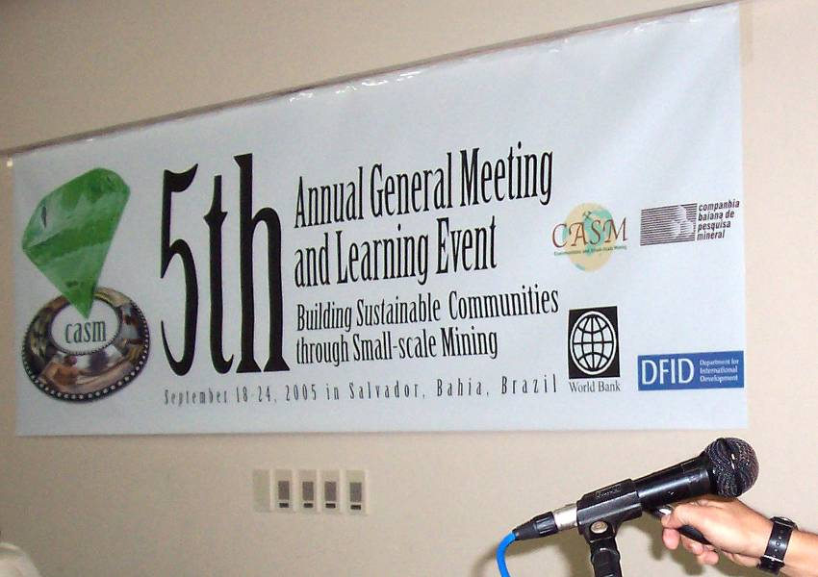

Registration and pre-conference CASM Business Meeting
Sunday, September 18

Program of pre-conference CASM Business Meeting

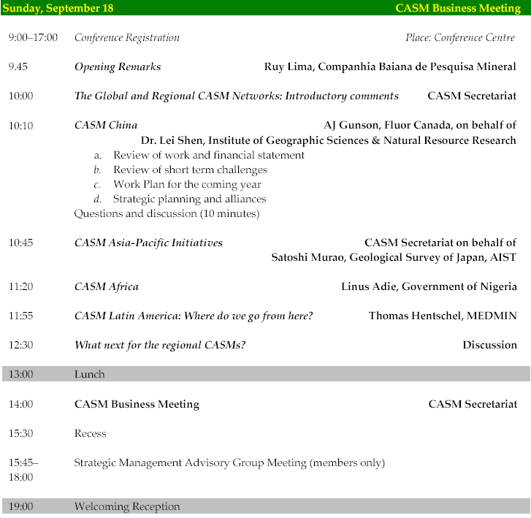

Technical Program, Day One
Monday, September 19, 2005

Program of morning session

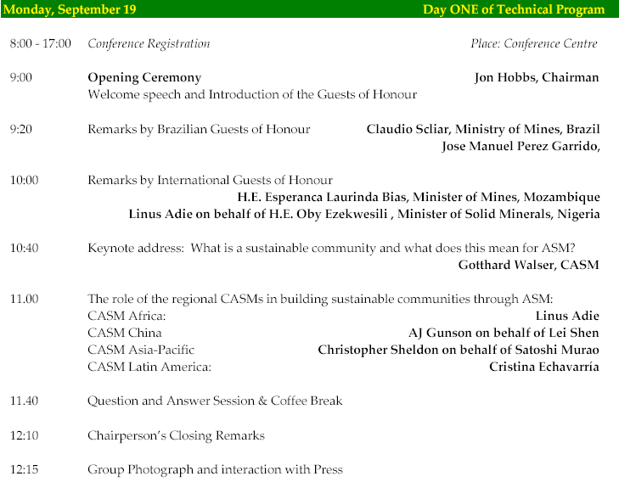

Remarks and presentations of morning session: Opening Ceremony
Monday, September 19, 2005

John Hobbs, UK Department for International Development, Chairman of CASM:
Jon Hobbs opened the meeting with an overview of CASM’s history and comments on its current priorities, including raising awareness about such issues as the Millennium Development Goals, child labour, environmental concerns, and the role of government in combating poverty. He stressed that implementation of the technological, structural, economic, environmental and societal improvements needed to effect meaningful, positive change in artisanal and small-scale mining communities would require time; the process cannot be complete overnight, but progress can be achieved over time.
Mr. Hobbs concluded with remarks welcoming the guests of honour and all participants.

Claudio Scliar, Federal Secretary of Geology and Mines, Ministry of Mines, Brazil
For the Federal Government of Brazil, represented by the Ministry of Mines, Claudio Scliar expressed his great satisfaction that CASM had decided to realize the 2005 Annual General Meeting in Brazil. Brazil has a long mining history due to its exceptional endowment with mineral resources, and many of Brazil’s mines are among world’s leading mining operations. On the other hand, Serra Pelada had involuntarily brought ASM to the world’s attention.
Since the early days of Serra Pelada in the 80’s, the Brazilian Government and other stakeholders have learnt to address ASM issues in a much better way. Formalization and regulization of ASM are important issues in order to mitigate the negative impacts of garimpo activity. Mr. Scliar concluded expressing the expectation, that the results of the CASM learning event will contibute to make another important step forward.

José Luiz Pérez Garrido, Secretary of Industry, Commerce and Mining of Bahia, Brazil
For the Brazilian State Bahia, ASM is considered of vital economic and social importance and coexists with large, government promoted mining projects. In the semi arid areas of Bahia, small scale mining represents frequently the only opportunity for economic survival of the poor rural population. This becomes increasingly important, as climatic conditions threaten traditional agricultural occupation.
The Government of Bahia considers it a priority to implement a series of activities directed towards remediation of known bottlenecks for development and especially the promotion of ASM, and as such focuses on environmental issues, infrastructure, energy and water supply, eradication of child labour, and improvement of training opportunities for artisanal and small-scale miners. An important contribution is expected from the PRISMA program (Program for Social Inclusion in the Mining Sector) which offers training facilities to unskilled workers in order to enable them to engage in artisanal mining activities such as dimension stone production or other artisanal mining projects. These projects are closely coordinated with SECOMP (Secretary of Combat against Poverty and Social Imbalance).

H.E. Esperança Laurinda Bias, Minister of Mines, Mozambique
ASM is a significant source of income and employment opportunities in Mozambique, where 70% of the population lives in rural areas. The government relies on mining activities to contribute to its poverty reduction initiatives and promote economic and social growth, rural development, and responsible use of resources.
In fact, ASM is the only income source available in many communities. The resulting over-exploitation of resources, in combination with the use of rudimentary methods, leaves these communities at high risk of facing significant negative environmental impacts as well as public health and social concerns. The scope of the problems extends beyond environmental degradation and water management issues to compromised agricultural and fishing industries, HIV/AIDS, mercury problems, and the lack of sufficient and adequate hospital and educational facilities.
The country’s new mining law, which covers and more clearly defines legal aspects of ASM, attempts to address these problems. It defines ASM as mining activity undertaken by individuals or collectively by groups who use rudimentary tools and whose efforts yield small volumes of mineral resources. The law designates areas in which ASM may be carried out and specifies that only national citizens or foreigners with resident status may engage in it.
Looking beyond the legal boundaries, the country is exploring and implementing laws, technologies and programs that can reduce negative environmental impacts and increase training and awareness about the importance of protecting the environment. At the same time, programs are underway to promote craft and other activities that can reduce the exclusive dependence on ASM for income and increase the diversity and robustness of the economy at the community level. These actions, taken in tandem with improved governing of ASM activities along with HIV/AIDS reduction and other health care initiatives, are key elements of long-term poverty reduction in Mozambique.

Linus Adie, on behalf of H.E. Oby Ezekwesili, Minister of Solid Minerals, Nigeria
As in most African countries, sustainable ASM communities in Nigeria are critical elements of economic survival, and reform strategies must take their importance into account. However, the informal mining process in Nigeria too often increases the poverty it is meant to address and introduces a social structure imperilled by such long-term community costs as drug abuse, disease, and corruption.
In recognition of ASM’s integral role in its economy, the government seeks the guidance necessary to gain a better understanding of the sector, devise appropriate long-term economic programs, and develop alternative livelihood activities. The country recognizes that when implemented in concert, these steps can promote community development and contribute to meeting MDG targets.
To that end, Nigeria is developing mining codes intended to foster sustainable development of resources. It has implemented computer based mining and enacted its ASM law. An extensive program of profiling and baseline studies is underway (the first has already been completed) and the outcomes will be factored into the development of new strategies for meeting environmental, legal, and social best practices standards. The goal is to reconfigure ASM in such a way as to make it an element of economic development and poverty reduction.

Gotthard Walser, CASM Secretariat, Mining Department, World Bank Group
CASM’s Mission is to reduce poverty by supporting integrated sustainable development of communities affected by or involved in artisanal and small-scale mining in developing countries.
As international aid resources are insufficient to meet the Millennium Development Goals (MDG's), in many poor areas of the world, mining - including ASM – represents an opportunity to “growth” and “sustainability”. However, the concept of “growth” must not be limited to the economic dimension and sustainability is not only about future generations: it also applies to people today. Both concepts point towards providing for better life, better governance and better environment.
Building sustainable communities requires the active participation of many different stakeholders; the ASM miners cannot do it alone! The Community Driven Development (CDD) Approach provides a framework for concurrence of stakeholders like ASM organizations, communities, community-based (CBO's) and non governmental organizations (NGOs), local authorities, government, financial sector as well as other sectors and businesses.
CASM’s role in building sustainable communities consists mainly in knowledge sharing (through events, publications and other media) and link creation (facilitating involvement of Governments or Development Agencies projects). To a lesser and relatively limited extent CASM may contribute financial resources to specific projects, applying schemes like “Small Grants” or DGF.

Group Photograph

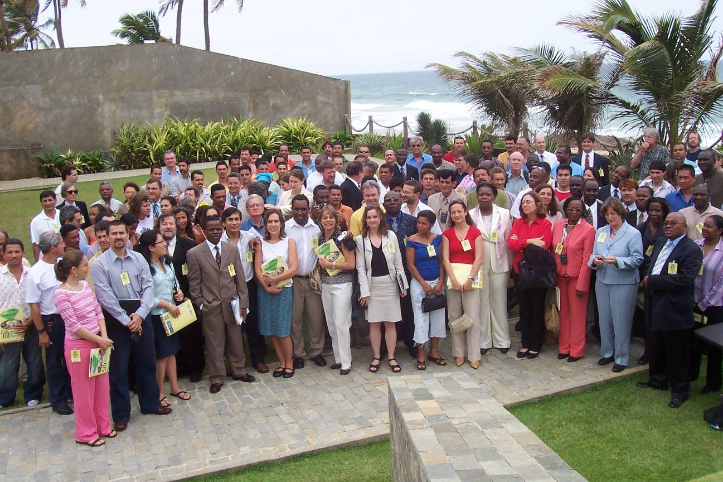

Program of afternoon session
Monday, September 19, 2005

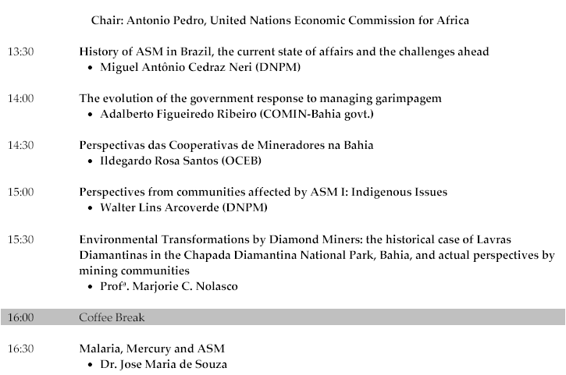

Presentations of afternoon session
Monday, September 19, 2005

Miguel Antonio Cedraz Neri (DNPM): History of ASM in Brazil and challenges ahead
Brazil’s history of ASM mining closely parallels its struggles in the move from colonial times to independence. The cycle of gold mining began in 1690 in Minas Gerais, Mato Grosso and Sao Paulo; diamonds were discovered in 1729 and followed two primary cycles, 1730-1828 and 1850-1889. However, much of this wealth was diverted to the Portuguese crown, which orchestrated a contract of exclusivity and in 1772 established a royal monopoly. The crown’s appetite for gold and diamonds also helped fuel the slave trade to provide the cheap labour necessary to meet production demands.
Following independence and the introduction of more advanced technologies, both big and small-scale mining operations expanded rapidly. A 1946 law established the federal government’s ownership of all underground mineral resources. Since 1988, the government has given preferential treatment to gold and diamond mining cooperatives; activity by individual miners is prohibited unless expressly permitted by the land owner.
ASM and medium-scale mining play an enormous role in contemporary Brazil’s economy; together, they account for 25 percent of formal and up to 40 percent of informal employment. They further play a critical role in industrial development and resulting employment opportunities, which rely on ASM and medium-scale mining to provide clay, sand, gypsum, and various other minerals tied to this area of economic growth. The industry is confronting such problems as excessive informality, loss of deposits, use of obsolete technology, poor administration, and inadequate understanding of the market and strategies for commercialization. ASM miners also need stronger protections against cartels. Investments are underway to address these concerns and to meet the goals of eradicating child labour by 2010 and integrating ASM into a comprehensive strategy for reducing poverty, promoting regional development, and ensuring miners’ full participation in the mainstream economy.

Adalberto Figueiredo Ribeiro (COMIN-Bahia government): The evolution of the government response to managing garimpagem

As in Brazil as a whole, Bahia has a history of mining that features many parallels with the history of colonization and independence, dating back to the first discovery of gold in Brazil in 1560 or diamonds in 1730. During colonial times, monarchy and the recent republican period, mining occupied always a particular position within the Brazilian industry’s evolution, and has been always influenced by the cultural priorities of the indigenous people who place great importance on the preservation of their livelihoods and traditions. Central government did not really intervene in Bahia’s small-scale mining operations until the 1970s, at which point it had to confront organizational, technological and procedural structures that had been in place, and had been left largely unchanged, since the late 1600s. Before 1988 garimpo activity was authorized under individual licences (matricula). The new Federal Constitution of ’88 changed this paradigm towards a licensing system favouring miner’s associations and cooperatives. Later, the law 7805 introduced a liberalization of this system, converting the former “garimpo reserves” into areas with preference to Garimpo, and at the same time requiring environmental licenses also from ASM operations. However, until today, garimpo activity has not been able to break its vicious circle causing some operations to remain “large scale operations with rudimentary technology”. There are many functions that could, with investments, be mechanized but continue to be handled as manual operations. Striking the right balance between production progress and protection of indigenous traditions will be a matter of achieving ongoing communication and cooperation among all members of the community, industry and government.

Ildegardo Rosa Santos (OCEB): Perspectives of the Bahia Mining Cooperatives
The mineral economy in Brazil is strong, but the mineral wealth is controlled by the medium- and large-scale companies while ASM communities subsist in abject poverty around them. This situation has been unchanged since colonial times, although certain political forces are making an effort to assist the garimpos.
One reality with an impact on implementing change in Brazil is the huge gap between the law as it is written and as it is practiced. Cultural, historical, and other factors continue to have such influence that notwithstanding the adoption of new laws, the miners’ situation has barely changed. Moreover, government attitudes shift frequently, which leads to inconsistent application of laws and policies. Only a few initiatives for organizing miners have achieved desirable results, and thus in Bahia, ASM is struggling to survive, and those cooperatives that to date have managed to survive are doing so in part through increased reliance on the sale of handicrafts.
Continued and improved organization in cooperatives is the only real option open to ASM miners. By creating strong cooperatives, the ASM miners can protect their rights against the large corporations and gain continued access to legal mining permits. Grassroots organization is the key to ensuring that ASM miners can attain consistent legal status, recognition within the industry, and the political clout necessary to break the cycle of poverty.

Walter Lins Arcoverde (Federal University of Rio Janeiro): Perspectives from communities affected by ASM - Indigenous Issues
The present distribution of ASM in Brazil encompasses 200 mining districts, with small scale mining organized in productive clusters. Workers of all ages are engaged in ASM; child labour has been found in one area, and in another, 60 year old women are engaged in producing sand.
Conflict can arise in areas in which mining sites are located on indigenous lands and nature reserves that put the miners’ interests at odds with those of other groups. The Ministry of Mines and Energy is attempting to ameliorate the situation by granting mining titles and via further regularization of productive clusters that follow an articulated work plan. Registering areas, issuing permits, promoting regularization, requiring protective equipment, providing technical guidance, and instituting regular inspection campaigns are all seen as contributing to increased stability and improved labour security.
In conflict areas, the government is working on a mining allotment strategy that would allow large-scale mining operations to be established but would assure that ASM workers are employed in those operations. Satellite photography is playing a role in locating areas in which illegal mining activity persists; when discovered, the operations are shut down and equipment is confiscated. In one instance, 166 carats of diamonds were confiscated from indigenous people and put up for auction.
More resources must be devoted to ASM to decriminalize and regulate activities and protect the rights of miners so that progress can continue. Priorities also include environmental licensing, improving market access and value, and building capacity and infrastructure.

Prof. Marjorie C. Nolasco: Environmental Transformations by Diamond Miners: the historical case of Lavras Diamantinas in the Chapada Diamantina National Park, Bahia, and actual perspectives by mining communities
This region has grappled with two ongoing areas of mining-related conflict: those related to the destruction or preservation of the indigenous culture and its traditions, and those related to concerns about environmental protection as a priority that must be balanced against economic and development objectives.
Environmental degradation has taken many forms. Mining generated an increase in sediment production that transformed the river to the point where it ceased to be navigable except at the height of the rainy season. The destruction of the river basin also caused changes in vegetation and, in turn, the forest and the savannah. In addition, erosion has accelerated.
This national park area is attracting a growing number of tourists, and their interests and environmental impact now also factor into the environmental and cultural balancing act in a region whose indigenous population has made the preservation of the ASM tradition a priority. The community recognizes the need to recover the river and forests, reduce or eliminate chemical contamination, and improve air quality. At the same time, however, community members still attach importance to the idea of passing the mining culture on to the next generation. Maintaining equilibrium among these interests will require an ongoing commitment from all stakeholders.

Jose Maria de Souza: Malaria, Mercury and ASM
In Bahia, small-scale mercury mining has contributed to increased presence of mercury in fish. Human ingestion of the amounts of mercury found in seafood has been linked to negative health impacts on the brain, kidneys, and cardiovascular function and contributes to suppression of the immune system, which opens the door to increased incidence and severity of infectious diseases. This is a health issue of global magnitude that threatens the populations of developed as well as developing nations.
An equally alarming problem is the worldwide rise in cases of malaria, which has become a problem in Bahia as the river flow was disrupted, which has increased the abundance of mosquitos, and as the area’s population has grown to include more migrants from the Amazon region. Experimental research on malaria is underway via a study of animals and humans.
These health issues ad another layer of complexity to Bahia’s existing ASM-related environmental concerns, which include deforestation, an altered aquatic system, reduced stream flow, and soil erosion.

Gildasio Amorim Carvalho, Carnaibas: Perspectives from Local Garimpeiros I
Many people are financially dependent on ASM. Investment funds will be needed to provide them with greater support and help them to overcome the difficulties they face and develop new opportunities. Provision of a line of credit for ASM could greatly improve conditions in the region. It’s also important to recognize that ASM workers fear creation of a monopoly by big companies who are seen as presenting a threat of domination in the region. The needs of rural and farming communities need to be given concurrent consideration; for example, tailings rich in potassium could be used for farming.

Claudionor Costa: Perspectives from Local Garimpeiros II
The 1990s were years of great suffering for miners, who faced repression, accidents, inadequate security, and even massacres. This spurred the creation of a miners organization that has succeeded in improving miners’ rights; subsequently, a cooperative was established for collective problem-solving and to seek improved funding solutions; the next step is the creation of a union to improve all the cooperatives’ productivity and market access.
With regard to concerns about mercury, it’s important to examine them in the larger context of the pesticide usage and other environmental damage inflicted by large corporations; it would be a mistake to concentrate too much focus on mercury. Solutions should include educational and environmental programs that address these problems and, at the same time, enhance value and production.

Dorivado Junior of Coritambe: Perspectives from Local Garimpeiros III
South-eastern Bahia is a poor community grappling with chronic unemployment and hunger. Mining and fashioning stone handicrafts figure prominently among the few employment opportunities in the area, which is rich in quartz, aquamarine, and other semi-precious stones. The disintegration of the cooperative, which closed for six years but more recently have been resuscitated by young people, exacerbated these problems. Greater organization, investment and support are needed to move this community to a more profitable and stable economic position, and the revitalized cooperatives stand poised to help coordinate this new investment.

Representatives of COOAMAC: Perspectives from Local Garimpeiros IV
Early cooperatives, particularly those associated with amethyst mining, had the support of local communities but not of the state. Later, they gained the support of unions, which promoted greater stability and cooperation. To address safety concerns, the cooperative has invested in safety equipment and provided access to doctors, dentists, engineers, and marketing professionals as well as a local police station. Additional benefits include transportation to the high school and other educational institutions that provide training courses, maintenance of clean streets, organization of sports leagues, and construction, with the active participation of community members, or new housing. The resulting population growth has spurred the opening of new stores and businesses. Notwithstanding this progress, the cooperative (Cooperativa Mista Agropecuaria e de mineracao de brejinho das ametistas) still faces problems and limitations, and state support would aid it in meeting its objectives.

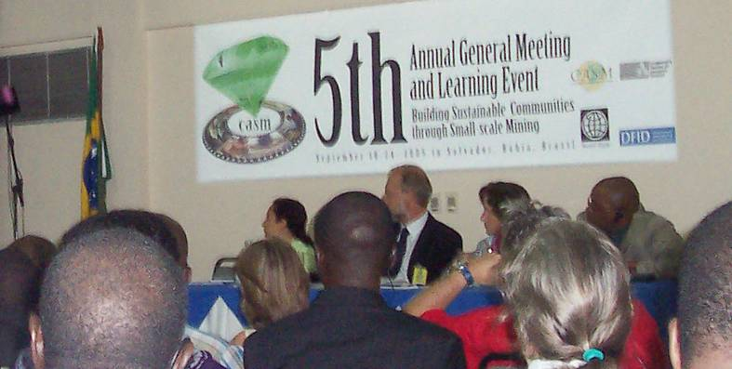

Day Two of Technical Program
Tuesday, September 20, 2005

Program of presentations of morning session

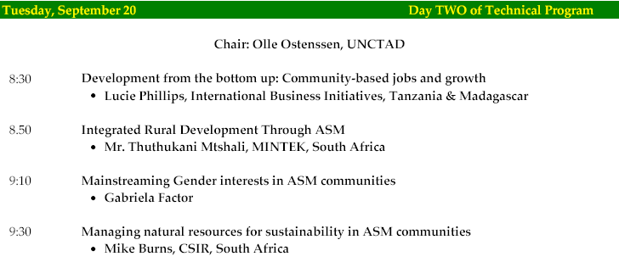

Presentations of morning session
Tuesday, September 20, 2005

Lucie Phillips (International Business Initiatives): Development from the bottom up: Community-based jobs and growth
International Business Initiatives has worked in Tanzania and Madagascar for the past decade. Its initial perspective on ASM was negative and associated the industry primarily with such social and economic ills as smuggling, abuse of child labour, and inefficiency. In Tanzania particularly, ASM was seen as something to be eliminated so that large-scale mining could take over. But as the company’s studies of the local mine to market chain revealed, large- and small-scale mining generate very different benefits. LSM attracts capital investment, generates tax revenue, and increases foreign exchange, but ASM is a critical source of employment and income for the poor and middle classes.
On the surface, LSM appears to be more efficient and not plagued by ASM’s irregularities and problems. With its costs delayed and its environmental plans fairly sound, it can be easy to overlook the impact of the eventual mine closure and the possibility that ultimately its costs will exceed its benefits—and that those costs will be borne by future generations, particularly in terms of the choice to be made between suffering toxic effects or paying for cleanup. ASM, conversely, is responsible for 550,000 jobs that cumulatively produce a huge increase in middle-class income: $6/day versus $1/day for farming. In addition, local stakeholders reported that notwithstanding acknowledged problems in ASM, it had made possible the opening of new roads, construction of new housing and businesses, opening of a new clinic and pharmacy, improvements in the local social life, and increases in discretionary income. Based on these factors, Tanzania reversed its position on ASM’s elimination by LSM.
Today the focus has shifted to what can be done to accentuate positives and mitigate negatives. Priorities include further job creation, reducing environmental impacts, and addressing the smuggling issue, which investigations have shown to be driven more by convenience than by price. A reduction in transaction taxes - to be replaced by royalties and corporate taxes - is another priority, as is adoption of an incentive approach and development of a business plan to increase market awareness and leverage ASM’s synergies with tourism.

Thuthukani Mtshali (Mintek): Integrated Rural Development through ASM: South African case study
South Africa’s integrated rural development initiatives have been closely aligned with development projects designed to lift communities up economically and socially. Historically, it has addressed issues related too migratory labour and workers not participating in the local economy. As mines were expanding, the perception was that it did not need to focus on ASM. However, now that the mining industry is in a period of contraction, expatriate miners are returning to rural areas, and increased mechanization is decreasing the availability of jobs, ASM is in a period of growth.
The Local Economic Development Plan (LEDP) is a social and economic development mandate issued by the local government. It makes funds available for job creation in agriculture, tourism, manufacturing and ASM. Municipalities need help from the government, state corporations and NGOs to develop capacity, leverage resources, and accelerate poverty reduction programs. Challenges include developing strategies to improve coordination, delivery capacity and economies of scale and to promote increased sharing of technologies and resources. The long-term objective is to promote sustainable development through ASM and integrate it within the mainstream economy.

Gabriela Factor: Mainstreaming Gender in ASM: Women Mining in Bolivia
Bolivian women who engage in mining are “invisible” to the extent that they are excluded from legislation and from decision-making roles in communities. Their needs are different from those of men in the mining communities, but these needs are not addressed or even recognized either legislatively or within the power structure of the communities. On paper, they have basic rights, but in practice they cannot exercise these rights. Their inability to access information and the larger society available in cities, travel to which is both physically difficult and too expensive, leave them isolated geographically, socially, and informationally. In fact, communication is limited even among women in these communities. Furthermore, their location in remote areas increases the expense involved in undertaking a project; here, again, the high cost of transportation comes into play. Apart from the practical problems these issues raise, their impact on women’s self-esteem has been severe.
Lessons learnt from gender oriented development projects include: (i) Needs assessment requires covering rights, resources and voice of women, (ii) Formal strategic alliances are important, but communication works best on informal level, (iii) The methodological approach “Reflect-Action” has proved to be very effective, (iv) Participative processes result in empowerment but require time. One of the most effective and most inexpensive tools to raise gender awareness or to “mainstream” gender is to demand disaggregated information or data on any issue.

Mike Burns (Council for Scientific and Industrial Research, South Africa): Managing Natural Resources for Sustainability in ASM Communities
There are two approaches to quantifying natural resource value. The first simply assesses the intrinsic environmental value of the resource. The second folds into the equation it’s utility to humans and ecosystem services, which fall into four categories: provisioning services, food, water, and wood; regulating services, which encompass climate, floods, and diseases; cultural services, which may be aesthetic, spiritual, or recreational; and supporting services (soil nutrients).
In determining natural resource value according to the second formula, we take into consideration whether human beings’ basic needs are being met, which in turn plays into the Millennium Development Goals and the parallel Millennium Ecosystem Assessment. A healthy environment is fundamental to meeting the Millennium Development Goals. The Environmental Sustainability Index and Human Well-being index are closely linked.
Ultimately the challenge is less the management of natural resources than management of complex, closely coupled socio-ecological systems. These requires adaptive management strategies, just as resolution of non-ecological system issues requires that stakeholders organize to increase the political bargaining power of the sector and make it attractive to stakeholders and government.

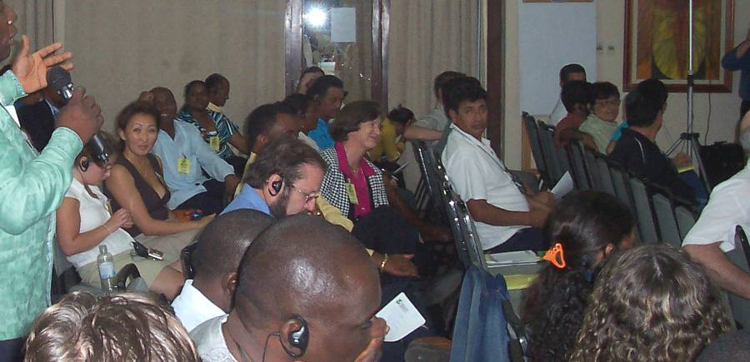

Program of morning session breakout groups
Tuesday, September 20, 2005

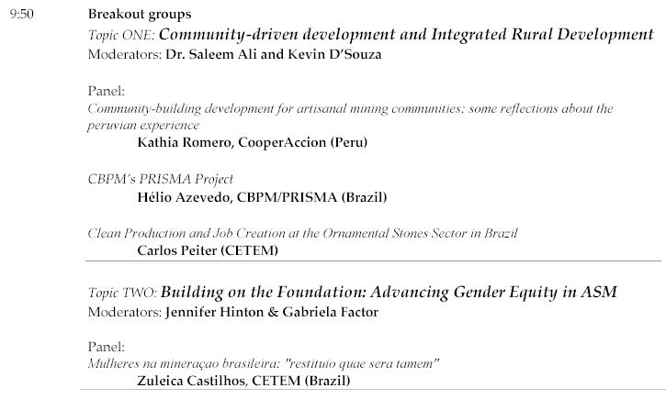
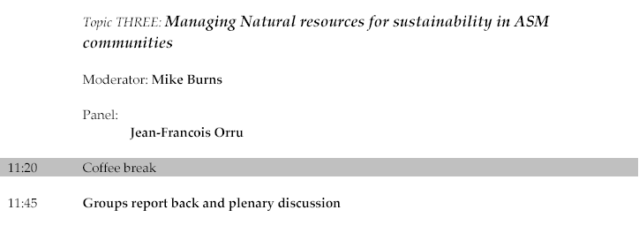

Notes from morning breakout groups
Tuesday, September 20, 2005

Group: Community-driven development and Integrated Rural Development
Moderators: Saleem Ali and Kevin D’Souza
Kathia Romero of CooperAccion (Peru) discussed “Community-building development for artisanal mining communities: some reflections about the Peruvian experience.” Included in this presentation was an explanation of Law 27651, which gave legal recognition to ASM. Also noted was the importance, as borne out by the Peruvian experience, of motivating local communities to participate in the legal process, interface and cooperate with the state and local governments, and engage in collective decision-making. The presentation stressed that local communities do have and can exercise a capacity for negotiating that addresses concerns about economic and environmental issues. The need to recognize women’s roles and ensure their voice in the process also was emphasized.
Hélio Azevedo of CBPM/PRISMA (Brazil), who reviewed CBPM’s PRISMA Project, a social inclusion program initiated in the state of Bahia, which has little arable land suitable for agriculture and therefore has a population highly dependent on ASM. PRISMA began as a state government project designed to promote income generation through the use of mineral goods and stones, production of artefacts, raw material, and civil construction. PRISMA aims at the implantation of various nuclei of mineral handicrafts and small productive units that utilize raw materials, principally scraps and tailings from the operations of pre-existing mineral extractions, to promote the generating of employment and income in needy communities in the semi-arid regions of Bahia. Besides the physical implantation of the units, the Program operates with professional stimulation of entrepreneurial capacity of the local manual labour, seeking to implant and consolidate productive activities, of extraction, of cutting, cleaning and polishing or processing of the minerals, aiming at the creation of business opportunities but, above all, seeking to make viable economic and social options for sustainable regional development PRISMA also is promoting the development of a commercial crafts market and mining-related parallel products. After beginning with gold mining in 2003, the project is scheduled to encompass a total of 349 projects by 2007 and is projected to benefit 7360 ASM miners with greater income-generating capacity that utilizes easily learned methods and is not dependent on the climate.
Carlos Peiter of CETEM (Brazil) focused on the topic, “Clean Production and Job Creation at the Ornamental Stones Sector in Brazil.” A key concern in this area is balancing the priorities of introducing clean productions techniques and ensuring jobs maintenance. The first step toward achieving that goal was the initiation of social, economic, and environmental studies completed in 1998. Today, the area most in need of further work is environmental, where some surprising win-win-options have been identified. An outstanding example is the successful mitigation of tailings- and sludge discharges into surface waters from cutting mills, which previously caused severe environmental concerns and protests from cattle breeders. The fines were found to be excellent primary material for different industrial applications. A ceramics industry has emerged to make mortar used in cementing tiles from cutting mill fines; this project, along with a new initiative in asphalt production using coarser material, or even the commercialization of rock chip tailings for ornamental gardens have saved jobs that otherwise would have been lost. CETEM also has fostered technology development and responsible public/private alliances with ASM companies. The CETEM experience plays up the need for successful organization and engagement of local communities, in this case aided by participation and support from the Catholic church; these elements proved more critical to success than sophisticated engineering innovations.

Group: Building on the Foundation: Advancing Gender Equity in ASM
Moderators: Jennifer Hinton and Gabriela Factor:
Panelist: Zuleica Castilhos of CETEM (Brazil) presented the summary and lessons learnt from the project “Mulheres na mineraçao brasileira: restituio quae sera tamem”, financed by IDRC and currently implemented by CETEM, UFRJ and UFOP. Occupation of women in the gold mine of Morro Velho is well documented since decades. The introduction of blasting in 1869 replaced most female workers from mineral extraction. In the 1930’s women working in mineral processing were replaced by ball mills. Many women still continue to work in artisanal mining, but as no data is available women’s occupation is invisible. The objective of the project was to investigate primary data about gender relations in artisanal and informal mining.
The results show clearly that women’s work is not adequately appreciated, and due to lack of organization, women are exploited. While women’s profit margins are minimal, their products (steatite as ornamental stone or even final products) are sold in Sao Paulo with middlemen’s profit margins of up to 1500%.
Organization and strengthening of self esteem of women are considered key issues for advancing gender equity.

Group: Managing Natural resources for sustainability in ASM communities
Moderator: Mike Burns of CSIR (South Africa): Natural Resources are one of the main spheres of sustainable development. Valuing natural resources has to take into account their intrinsic environmental value, as well as their instrumental environmental value related to ecosystem services. Human well-being is related to state of ecosystem services which can be measured by the ecological footprint, the "load" imposed by a given population on natural resources. The ecological footprint represents land area necessary to sustain current levels of resource consumption and waste discharge by that population.
Sustainable ASM demands key interventions regarding management of ecosystem services, such as (i) intensified, coordinated action regarding ASM access to potable water, (ii) address production deficiencies in protein and carbohydrates to meet basic nutritional needs and reduce hunger in ASM communities, and (iii) biodiversity-compatible management energy supply. Non-ecological system issues are probably even more important management: issues, such as organising ASM to increase the sector’s political bargaining power or increasing sector’s attractivity to stakeholders (investors, government, etc.). In conclusion, it is considered, that sustainability of ASM: has less to do with managing natural resources than managing complex, closely coupled socio-ecological systems
Panelist: Jean-Francois Orru of BRGM (France) commented about natural resources management in an ASM gold zone of French Guiana, providing a necessary balance between socio-economic stakes, environment sustainability and rural community’s stability. French Guiana can be considered a small part of Europe in South America, under-populated but coveted due to free health services, free schooling and possibilities of jobs with good incomes. This contrasts with ASM activities where decision makers need structured and regularly updated information to solve and prevent land-use and resource use conflicts.
Remote sensing is considered a valuable tool for ASM monitoring due to access difficulties and rate of landscape changes. Remote sensing provides a variety of scales, from global observation with high revisit capability (satellites), to detail level observation (airplanes), and offers a series of possibilities to monitor ASM activities over space and time, and draw conclusions for adequate resource management.

Program of afternoon session presentations
Tuesday, September 20, 2005

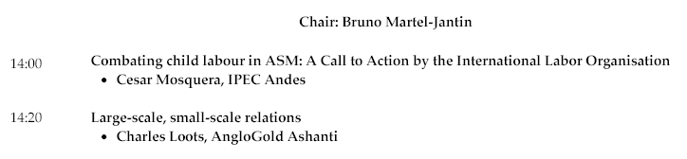

Presentations of afternoon session
Tuesday, September 20, 2005

Cesar Mosquera (ILO/IPEC): Combating Child Labour in ASM
The ILO/IPEC program pursues the progressive eradication of child labour on a world wide scale by strengthening of national capacities, mobilization of actors, awareness raising and development of direct intervention action programmes. ILO convention 138 about the minimum age for employment admittance and convention 182 about the worst forms of child labour and the immediate actions to eliminate have both been ratified by Brazil in 2002 and 2000, respectively.
According to results from the PNAD 2003 household survey 145.967 children and adolescents from 5 to 17 years old were working in mining related activities in Brazil. Through the Sectorial Pact between Federal Government, mining sector entities, mining sector workers unions and organized civil society, ILO/IPEC expects these figures to drop significantly in a near and medium-term future.
The Sectorial Pact defines and adopts plans and specific targets for the prevention and eradication of child labour in mining production chains, such as commercial restrictions against business that exploit child labour, support for social inclusion of those withdrawn from child labour situation, sensitization and social awareness campaigns amongst the families and local communities of children and adolescents in vulnerable situation. In partnership with public and private entities and with the civil society, IPEC supports solidary and cooperative actions aiming for income generation and professional training of the families of children withdrawn from the labour situation. According to the National Plan for the Eradication of Child Labour and Adolescent Workers Protection, ILO will contribute to promote the dissemination of good practices that may contribute to eradicate child labour in the Brazilian mining sector, monitor the implementation of the Sectorial Pact and help to evaluate, after a year, the obtained results.

Charles Loots (AngloGold Ashanti): Large-scale, small-scale relations
The root causes of the strained relationship between ASM and LSM can be traced to the region’s history. In the remote areas in which mining operations are in place, villages, their cultures and their social structure predate current borders and structures. The local people are not interested in alternative livelihoods and prefer to continue their traditions of many centuries’ standing. Under these circumstances, conflicts can easily arise over who has the right to exploit a resource, and convictions about what the local communities can justly claim as their own may outweigh respect for government concessions. Likewise, it is difficult to gain agreement to culturally-entrenched customs and procedures—from heavy use of mercury to use of child labour.
These conflicting interests can pit traditional communities, survivalists, fortune seekers and new arrivals against one another. As a consequence, employee safety is a key concern in ASM. Other challenges that need to be addressed are ASM’s association with dirty gold, production disruptions, use of mercury and other issues of environmental degradation, increased incidence of HIV/AIDS and malaria, substance abuse, poor relations with host communities, and increases in local crime.
AGA’s approach to addressing these issues has been to participate in discussion groups at mines and focus on building mutually beneficial relationships. Through this communication, the company gained a better understanding of such issues as access to credit, improved technologies, safety and health. At the same time, it promoted the benefits of legalization and organization. The development process must be as inclusive as possible and reflect the input and participation of all stakeholders.

Program of afternoon session breakout groups
Tuesday, September 20, 2005

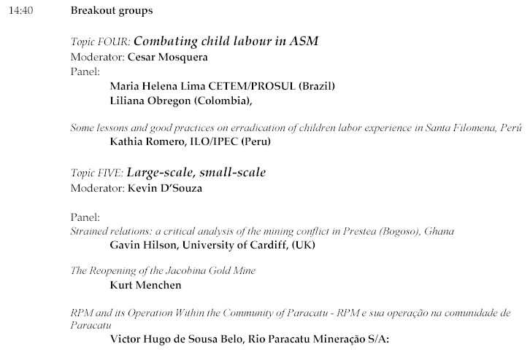

Group: Combating child labour in ASM
Moderator: Cesar Mosquera of ILO/IPEC (Peru): The action plan to eradicate child labour in ASM by 2015 is currently supported by 15 countries and several institutions, including CASM. Experience showed that child labour issues are closely linked with the whole spectrum of problems faced by ASM. Consequently, child labour issues can be considered an important entry point for transforming ASM into a socially and economically sustainable activity. The goal to eradicate child labour in ASM within the next 10 years characterizes admittedly a very ambitious action plan, but all participating stakeholder agree that achieving this goal would be an enormous step forward towards sustainable ASM.
Panelist: Maria Helena Lima of CETEM/PROSUL (Brazil): The project “Gender and Child Labour in South America’s ASM” links Brazilian researchers with experiences from Peru and Bolivia. The goal is to identify ASM related activities that are hot spots of child labour. Brazil’s child workforce is estimated at 5 million children, with about 150,000 related to ASM. Main activities occupying children resulted: charcoal production for metallurgic use, brick making and ceramics production, and dimension stone quarries. Strict legal standards, the risk of facing export restrictions on products related with child labour and alternative educational opportunities were identified as factors contributing most to eradication of child labour.
Further panellists of the group were Liliana Obregon (Colombia) and Kathia Romero of ILO/IPEC (Peru). Liliana Obregon commented on experiences of the Inter-institutional Committee for eradication of child labour working with emerald-, carbon- and gold miners in Colombia; Kathia Romero commented on good practices for eradication of child labour resulting as lessons learnt from the experience in the ASM community of Santa Filomena in Peru

Group: Large-scale, small-scale mining
Moderator: Kevin D’Souza: The historic conflict between ASM and Large Scale Mining (LSM) is often characterised by tension, mistrust and occasionally conflict. While the ASM sector is often viewed as ‘trespassers’ and a nuisance on LSM concessions, LSM concessions are perceived by communities and artisanal miners as depriving them of their ‘traditional’ land and rightful livelihoods. Both scenarios are well known: LSM using the ASM sector as unpaid ‘geologists’ or barefoot prospectors, and ASM illegally congregating around virgin exploration sites and newly developed LSM sites.
Lessons from the past show clearly that traditional LSM approaches like force, terrorisation, intimidation and building expensive security systems of security are in the long run almost always doomed to fail. As many partnerships in Africa demonstrated, diplomacy and building constructive relationships between ASM and LSM may deliver much better results. Co-existence may need a new understanding of the roles of ASM, LSM and the Government.
Panelist: Gavin Hilson from University of Cardiff, (UK) discussed “Strained relations: a critical analysis of the mining conflict in Prestea (Bogoso), Ghana.” The presentation began with the display of headlines about police shooting miners in Ghana, which dramatically underscored the complete breakdown of dialog among the parties. The country has faced numerous conflicts between large- and small-scale mining, particularly in relation to issues of relocation and compensation of ASM miners displaced when mines have been taken over by BGL. The Galamsay miners are not recognized by the government, which takes the position that they are criminals, and BGL has rejected attempts at dialog initiated by the miners. A proposed relocation site has been identified but not prospected, which raises the question of whether there is gold present that would sustain enough ASM mining to provide the miners with a livelihood. Alternate industries such as soap making and snail farming have been proposed, but no studies have been completed that support the notion that there is a market for these activities. Sustainable solutions under investigation include pond trout, cocoa farming, and rose gardens; the alternative is for BGL to relinquish a portion of the concession for ASM.
Panelist: Kurt Menchen (Brazil): addressed the topic of the Reopening of the Jacobina Gold Mine Gold was discovered in Jacobina, at the beginning of 18th century. Throughout the time from then until the current days the activity of prospectors has existed. In 1880, the Jacobina Mining Company began a small-mechanized mining operation with equipment imported from Europe, working until 1896. Other attempts of mechanization occurred during the decade of the 1950s in the twentieth Century. Large-scale mining was started by the Anglo American (South African) company in 1977, in the south of Jacobina, was closed during some years and reopened 2005 by Desert Sun Mining (also Canadian), with a projected production of 100,000 oz per year. Although large-scale mining has reduced ASM activities, artisanal miners have persisted. ASM is well organized and is not restricted by the large companies except in cases in which risks of accidents or mine collapses are identified. Unlike in Ghana, relations between large- and small-scale mining have historically been peaceful, and in accordance with government demand, the company has a stated obligation to address small-scale mining problems by helping the community to formalize and organize its structure and promote clean mining practices. This has complicated the matter of attracting foreign investment and raised questions about the financial and other implications of offering additional concessions, transferring technology to ASM, and determining who pays tax on production. Priorities include promoting a positive image of the advantages of the historical relationship and establishing a tax structure that stimulates or offers benefits to the company to ensure its continued acceptance of the existing relationship.
Panelist Victor Hugo de Sousa Belo from Rio Paracatu Mineração S/A (Brazil): discussed RPM and its operation within the community of Paracatu. The focus of this presentation was how to meet the goal of developing production within the context of sustainability and overall quality of life, beyond day to day mine operations. Achieving this goal requires respect for the community and all its stakeholders as well as a commitment to maintaining safe and healthy conditions. Though the parties’ relationship at first was reactive, it has evolved into on that recognizes the need for communication among all members of the community to optimize the potential for collective, collaborative development of alternatives. This is achieved by emphasizing transparency and open communication, both of which have been promoted via the creation of a partnership seminar that has established a forum in which to present, fully discuss, and approve new projects for funding and community support. The spirit of collaboration extends to consultation on community needs beyond the mines, such as the water park whose planning is now underway. Finally, the parties are working together to anticipate and prepare for life once the mineral resources have been fully exploited, with diversification efforts in areas such as tourism already underway. The overarching goal of these initiatives is to improve the quality of life of the entire community.

Day Three of Technical Program
Wednesday, September 21, 2005

Program of morning session “showcase presentations”

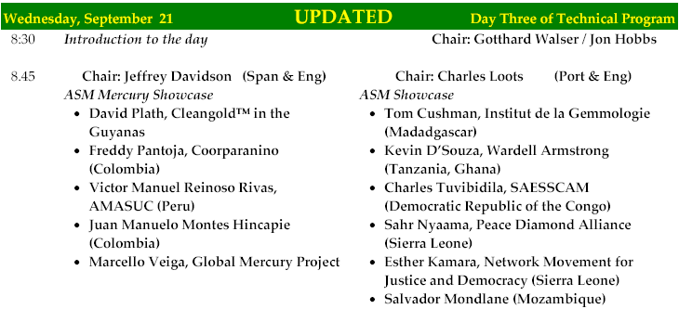

Morning session Showcase Presentations
Wednesday, September 21, 2005

Group 1
Chair: Jeffrey Davidson

David Plath: Cleangold™ in the Guyanas
Gold mining plays a significant role in the Guyanas. This mining activity correlates with increased presence of methyl mercury, which has shown up in human studies, because the traditional processing system employs sluices with mercury. Cleangold™, a lightweight portable separation system, provides an alternative that removes mercury from traditional sluice boxes, which allows gold to be mined profitably and with less damage to the environment and the population, and even in some cases recover mercury from tailings of former ASM operations. The system has now been tested and put into use in Europe, the Americas, Asia and Africa and is endorsed by the Institute for Sustainable Mining.

Freddy Pantoja, Corponariño Minga Project (Colombia)
The regional initiative MINGA, which ran from 2003 to 2005, had the support of various ASM associations in local countries working under the umbrella of UNESCO’s office in Montevideo. A pilot cultural project, it tested the model via six demonstrations in Colombia and one each in Ecuador and Peru. Under this model, miners were in charge of mining that used simple techniques to carry out processing in a small, appropriately located outdoor area and testing in a small laboratory. The object was to train the mining community to use technologies that would improve the gold amalgamation process and document the process. The technologies used still employ mercury and so do not meet the “clean” definition, but they do offer improvements over the former process.

Victor Manuel Reinoso Rivas, AMASUC (Peru)
AMASUC represents, protects and defends ASM in Peru, where there are 50,000 artisanal miners. The organization process of artisanal miners is still in its early stages. As recently as 2000, ASM was not covered by existing mining legislation. Addressing this issue had to be accomplished in stages. An initial step was conducting a capacity building workshop in 2001. This was critical to understand mechanisms of gaining government’s attention and addressing the mining sector (ASM and LSM) in a manner that allowed the participation of all stakeholders. It was also essential to promote knowledge of the importance of environmental studies to artisanal miners, to ensure that mining did not destroy areas or cause excessive depletion of mineral resources. Women’s role in the artisanal mines is another point of focus; it’s often difficult to get women involved in the miner’s organizations, which is considered a first level priority.
Law 27651, promulgated in 2002 recognized the existence of ASM for the first time, but many ASM communities are located in areas so remote that dissemination of information is still an ongoing challenge and an important responsibility of the organization. Therefore emphasis continues on formal registration of previously informal groups of artisanal miners in the interest of transforming mining into a business activity that generates improved revenue. Mercury and other environmental concerns also continue to be a focus.

Juan Manuel Montes Hincapie (Colombia)
The circumstances under which people engage in ASM in Colombia are not favourable, and strategies need to be implemented to improve the quality of work and life in the communities and address environmental and health concerns with a direct impact on the local population. Within the workplace, the issue of the presence of children and the elderly in the workforce demands attention. Areas of focus also include strengthening the production chain, improving safety, and advancing processes both within the mines and in the course of bringing the product to market. This last point applies to leveraging empirical knowledge, not merely technology.
Strategies should emphasize long-term solutions; identification of resources, for example, is being explored in terms of a window of 150 years. In order to implement the most comprehensive and effective solutions, policies are being developed with input from a broad range of sources, including the state, universities, mining companies, and associations of miners. The procedure will follow a fixed pattern that moves from identification of a problem to location of sources of financing and then communication to share the information gathered. This will serve not only to promote participation in nationwide mercury initiatives but also to promote social development and the creation of new social networks that, by extension, will be better prepared to confront such diverse issues as family violence, health, education, sanitation, and sustainability.

Marcello Veiga: Global Mercury Project
When gold started to rise in 2001, it caused the biggest gold rush the world has ever seen. Current estimates indicate 100 million people directly and indirectly involved in artisanal gold mining, producing 800 to 1000 tonnes per year from ASM worldwide. Conservative estimates of more than 1000 tonnes mercury released annually into the environment by ASM represent 30% of the man-made mercury pollution. Main reasons by which Hg is widely used by ASM are that mercury is easy to use and quite efficient, cheap, easily accessible, and that miners are generally not aware of risks.
The first phase of UNIDO’s Global Mercury Project (GMP) was devoted to environmental and health assessment. The second phase focuses on implementation, namely education of miners and communities, increasing efficiency of gravity concentration and reduction of Hg-emissions and exposure. Regarding reduction of mercury emissions, GMP follows a straight forward hands-on approach, promoting in a very flexible way any locally accepted simple technologic solution, as “any solution is better none”. Key to success is illustrative communication in-line with the host country’s cultural idiosyncrasy. This grass root strategy is complemented on policy level by use of GIS for risk assessment and to evaluate the growth and mobility of artisanal mining; creation of tools to establish mitigation strategies for mercury contaminated sites and development of land use plans; as well as proposals for economic diversification of mining communities based on natural resources vocation.

Group 2
Chair: Charles Loots

Tom Cushman, Institut de la Gemmologie (Madagascar)
The “projet de gouvernance des ressources minerales” (PGRM) is a program funded by the World Bank in Madagascar to improve the mining and gem trade sector.
Part of the project is the Institut de Gemmologie de Madagascar (IGM), a school of gemmology and lapidary as well as a gem laboratory. The IGM works in close collaboration with GEM-A of London and GIA of America. The IGM aims to contribute to development through education.
A program called “La Gemmologie pour Tous” or “Gemmology for everyone” is a gemmology course specially conceived for small scale gem miners and traders. The course is taught in the local Malagasy language. For this program, the teachers go the local remote villages to give the course to all interested persons free of charge. Over 600 people attended this course in 2005;

Kevin D’Souza, Wardell Armstrong (Tanzania, Ghana)
DFID’s ASM Development Project in Tanzania and Ghana follows a participatory approach with local community ownership. Drive-in partnerships with the public and private sector are considered a priority in order to obtain the following goals:
Promote co-existence with Large Scale Mining sector; Pilot sustainable integration of ASM into community development programmes and ASM into PRSP; Delineate and demarcate the mineral potential suitable for ASM exploitation; Encourage the formation of ASM associations or co-operatives and partnerships with the LSM; Provide outreach services - self sustaining technical assistance and training schemes; Provide a viable and sustainable financing scheme and a fair and effective marketing system and added value for ASM products; Define relevant and consistent health & safety standards and practices; Establish appropriate and realistic environmental protection practices and principles; Help establish and/or strengthen institutional capacity to handle and/or manage the ASM sector; and advise on the formation of an enabling policy and appropriate and transparent legislative framework and licensing scheme.
Assistance to the ASM sector will contribute to the attainment of the MDG's, as providing assistance to the ASM sector will help national governments and international donors join forces in the fight against poverty, illiteracy, hunger, lack of education, gender inequality, child and maternal mortality, disease, environmental degradation and unfair trade.

Charles Tuvibidila, SAESSCAM (DR Congo)
Democratic Republic of Congo is a great mineral country where Artisanal Mining and Small Scale Mining play an important role since 1984, resolving unemployment, and creating new settlements. Unfortunately many disorders exist. With the new Code, the DRC Government is only promoting private initiative, regulating framework conditions and expecting to collect taxes. Unfortunately, in the past and still today, cheating, fraud and smuggling remain unresolved issues. Even children labour is present.
According to all those considerations, the President of DR Congo signed the Decree Nº 047/C-2003 creating a public office named “Service d’Assistance et d’Encadrement du Small Scale Mining” with specific goals that can be summarized as follow: (i) to strengthen artisanal miners groups creating cooperatives and assisting with materials and funds if possible; training them in management skills, enabling them to become small scale and eventually large scale miners. (ii) In the rural areas where ASM is present, SAESSCAM contributes to community building by repairing roads, schools, hospitals. etc. (iii) additional to supporting ASM activities, SAESSCAM is also in charge of collecting taxes from the Small Scale Mining actors.
Ongoing projects in the Democratic Republic of Congo are: (i) C.I.A.T. (Comité International d´ Accompaniment de la Transition) is working with the National Institutions (Senate, Parliament, Government); (ii) MONUC (Mission des Nations Unies pour le maintien de la paix au Congo DRC) is active with the National Army and the National Police; and (iii) The World Bank helps the Ministry of Mines (Code Minier, Règlement minier, Training in Environmental and Social Studies for the Congolese Experts, implementation of the Mining Cadastre)

Sahr Nyaama, Peace Diamond Alliance (Sierra Leone)
Following significant reduction in hostilities in Sierra Leone, Cabinet established in 2001 the Diamond Area Community Development Fund (DACDF). This fund allocates 25% of revenue accrued from Diamond Export Taxes for the development of diamond mining communities. Contingent on the Sierra Leone government willingness and commitment, Donors would provide seed money/matching funding to the DACDF in order to sustain social and infrastructural development in ASM communities.
Matching arrangements are unclear but to date 54 chiefdoms with a combined 2,313 licenses have and continue to benefit from the fund. At 0.75% Diamond Export Revenue returns per chiefdom, from 2001 to 2004 end, a total of nearly $1,923,000 was paid out to mining chiefdoms by the government, with almost $850,000 in 2004 alone. However, disbursement of funds, community capacity to implement projects, monitoring and in recent times a pending decision to have NaCSA implement the Fund has provoked controversy.
It is now necessary to re-think the DACDF. The nature of the fund allocation, based upon legal mining licenses within chiefdoms, remains a positive aid to mine monitoring at the local level, especially as chiefs now realize the size of the benefit. However, community awareness remains low, questions as to how effectively the fund is used including limited utilization and accountability of the fund continues to be critical problems. The fund, possibly pushed through with some haste, now requires a solid working framework. It is possible that the original reporting structure envisaged would fulfil the accountability needs. This would however require considerable capacity building at the local level.

Esther Kamara, Network Movement for Justice and Democracy (Sierra Leone)
The continuing engagement of NMJD’s Campaign for Just Mining (CJM) in advocating and campaigning for better living standards of people in mining communities as well as for mining companies to carry out their activities with a human face has led to the commencement of the building of houses by KHL to relocate affected communities in Kono. The CJM first embarked on mobilizing and educating the people on the terms of the agreement the government signed with KHL and the contents of relevant legal instruments and policies on mining. Today, the people are now identifying advocacy issues, and initiating and implementing their own campaign and advocacy strategies with very little involvement by NMJD and they are scoring huge success despite a few occasional hiccups.
Also, the CJM has been able to engage and influence the government and other stakeholders to see the need to review the country’s existing mining policy which has become obsolete and not in tune with prevailing trends. Apart from reviewing the policy, the CJM observed that there was not much involvement of the civil society in the policy formulation process as evidenced by the too many government officials on the committees established for the exercise. However, after some engagements, government saw the need to not only review, but to give the people a chance to play a role in the process as well. Today, there is a review of the core mineral policy in progress. The mining laws are also undergoing reform by the Law Reform Commission.

Salvador Mondlane (Mozambique)
Studies show that the main attention is given to the Environment, to the communities, to the geological conditions of the deposits and very little is given to the proper miner in terms of its safety. At best of our knowledge it is only the Philippines that have specific regulations for the ASM. In all other countries mining is regarded as mining in terms of law (regulations etc.). But ASM has specificities in terms of mining methods and conditions, organization and motivations which are different from the LSM.
Presently, ASM in Mozambique produce 100% of the country’s gold and it is also an important source of livelihood and poverty alleviation for many residents. However, ASM lacks financial and technical resources which lids to haphazard and wasteful mining, inefficient mineral processing, illegal trading, precarious living and working conditions, as well as severe environmental and social problems. In consequence, every stage of the artisanal mining cycle in Mozambique is unsafe and unhealthy for both miners and surrounding communities.
The health and safety regulation for ASM in Mozambique is structured as follows: mining area, work organization, equipment for individual protection, extraction, transportation, washing, processing and concentration of ore, social infrastructures and environmental rehabilitation and restoration

Morning and afternoon session workshop program
Wednesday, September 21, 2005

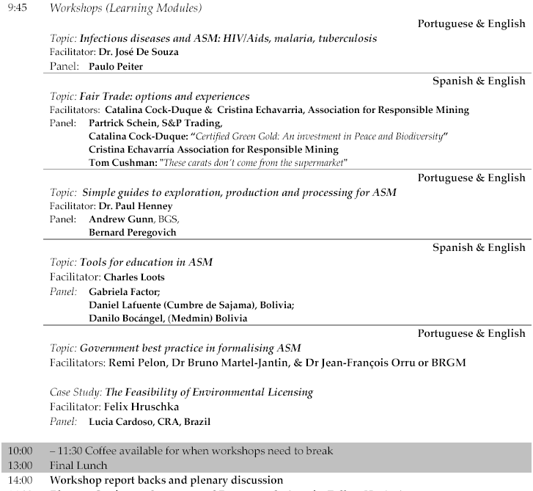

Workshop summaries
Wednesday, September 21, 2005

Learning session: Infectious diseases and ASM - HIV/Aids, Malaria, Tuberculosis
Note: No written summaries of this learning session available

Learning Session Fair Trade - Options and experiences
Representatives of all stakeholder groups and every continent came together in this session to initiate an ongoing conversation about the role fair trade can play in transforming aspects of the ASM sector. The issue was examined from perspectives as diverse as those of the Green Gold Programme in Colombia and sapphire mining in Madagascar. Its complexity was further underscored by discussion of the differing principles of fair, ethical, green and solidarity trade and the social, economic, environmental and labour concern on which each focuses.
Points of convergence for ASM and fair trade were shown to be particularly strong, as fair trade proponents share the poverty reduction objectives of the MDG and CASM. It is a market-driven approach designed to benefit the poorest communities and producers and requires their active acceptance and involvement in order to succeed. Further, it promotes the elimination of those intermediaries who add no value to the production and marketing chain. Although those intermediaries must be identified on a case-by-case basis, minimizing their profit participation makes it possible to allocate increased resources for reinvestment in the communities.
Session participants agreed that fair trade initiatives launched within the sector should be kept simple and should not be expected to be universally applicable in all ASM situations. (An example cited was that of a “rush” in which hundreds of people who have neither an organizational structure nor consciousness of/concern for human rights and environmental impacts arrive seemingly overnight to exploit a mineral-rich area.) It is, however, well-suited to community mining in which indigenous people mine their own resources within the area in which they live and to which they have a strong ancestral connection.
Fair trade also relies on the active participation of educated consumers, and the Fair Trade Label Organization has already established the framework and language in which to convey concerns to those consumers. Therefore, participants agreed, CASM must establish a partnership with the organization to incorporate its knowledge and practices within ASM. That partnership could extend to the development and implementation of certification standards and labelling, in concert with similar efforts underway to eliminate child labour.
The session also touched on the question of how to calculate a fair price. One proposed formula involved combining local cost of living for a mining family with the international price of the commodity to define the percentage of the prime. However, as community miners may derive their livelihoods from diverse economic activities, development of an equitable formula will require further consideration. Also in need of additional discussion is the question of what percentage of a certified product must originate in fair trade. Those percentages range across nearly the entire spectrum now and should be addressed in the context of continual improvement.
Several action steps emerged from the meeting. In the interest of simplicity, session participants agreed that gold would serve as the best pilot case, and ARM agreed to develop a preliminary draft of fair trade standards for ASM gold that would incorporate ideas and practices already articulated in the Lima Vision, the Fair Trade Label Organization’s standards and criteria, and CASM’s framework for sustainable ASM communities. This draft will undergo internal review by people on the Fairtrade list, other key participants from Africa, Asia and Latin America, and others identified at the CASM meeting. A first draft that incorporates their comments will then be published on the CASM, ARM, and other key web pages to invite further feedback. The issue will be included in the agenda of future CASM meetings, with coordination by Christopher Sheldon.

Learning session: Simple Guides to exploration, production and processing for ASM
In his introduction, Paul Henney indicated that huge volumes of information on exploration, Production and processing are available, but the main questions, especially for artisanal miners, are: who has the information? Is it accessible? Is it relevant? What information do YOU need? HOW do you need it supplied?
Gus Gunn continued with a lecture on mineral deposit types, mineral exploration, assessment of resources (especially sampling) and the importance of metallurgical testing for proper design of mineral processing flow sheets. Knowledge of these issues is considered also a key issue for ASM operation’s success.
Bernhard Peregovich reinforced the lesson with a case study from Pará and Amapá (Brazil), directed towards special training for small scale gold miners. An UNESCO project, specially designed for small scale mining communities and associations was carried out by a team of experts from NAEA – UFPA, focusing on accounting, exploration and environmental aspects. Theoretical and practical teaching was given in cooperation with the local mining association AMOT in the Tapajós region at garimpo Canaã and with the co-operative COOGAL in Lourenço – Amapá. Lessons in accounting provided information about any costs for gold exploration considering the day-to-day routine and the circumstances in the garimpo. Lessons in basic exploration and calculation processes enhanced the miners understanding for selective choice of a potential area for profitable mining. Lessons in environmental aspects, finally, made them aware for needs in avoiding harmful impacts to nature as their own and only habitat.

Learning session: Tools for education in ASM
Note: No written summaries of this learning session available.

Learning session: Government best practice in formalizing ASM
Part one of the workshop focused on best practice in formalising artisanal and small-scale mining. The aim of the workshop was to present and discuss a Guidance Note on legislative efforts towards the formalisation of ASM. Based on a global review and a comparative analysis of mining codes and policy approaches towards ASM, a BRGM/CASM research project comprises a set of reflections, illustrations and recommendations dedicated to governments, consultants or other experts who determine the legal aspects of formalisation processes.
After analyzing successes and issues of existing legislative instruments dedicated to ASM and presenting a preliminary framework of recommendations, participants discussed what a law should specify for appropriately formalising the activities of a given artisanal mining population. Participants expressed their opinions and the lessons of their diverse experiences. Comments and conclusions will be integrated in the final draft of the Guidance Note.
Part Two had the goal to provide an overview of existing environmental licensing policies, procedures and requirements for ASM in different countries, and develop new ideas and develop innovative alternatives. Environmental licensing is one of the hard steps for artisanal miners towards formalization. Environmental licensing is expected to contribute towards improved environmental conditions in the area of influence of ASM operations. In order to achieve this goal, compliance with environmental requirements needs to be enforceable. In general terms, environmental compliance of artisanal miners is low. Is this a consequence of environmental requirements, licensing procedures, or enforcement mechanisms? Is environmentally compatible ASM possible?
Starting out with a presentation of the Brazilian case, participants were invited to summarize environmental licensing policies and approaches in their countries, and compare experiences and lessons learnt from different regions, both from the government’s and private sector’s point of view. A subsequent brainstorming session, where participants discussed environmental requirements, environmental licensing models and procedures, and enforcement mechanisms ended the workshop with conclusions regarding to their applicability to the Brazilian case and for other countries.
A clearly visible difference in participant’s viewpoints and contributions during discussions of both parts of the workshop originates from diverging, culturally fundamented understandings of the Government’s role. While some participants, mainly from Africa, insisted on the Government’s role to identify areas suitable for ASM reserves and the need to focus on formalization of miners within these reserves, the general point of view of Latin American participants reflected the individual’s right and responsibility for prospection and obtaining mining licenses.

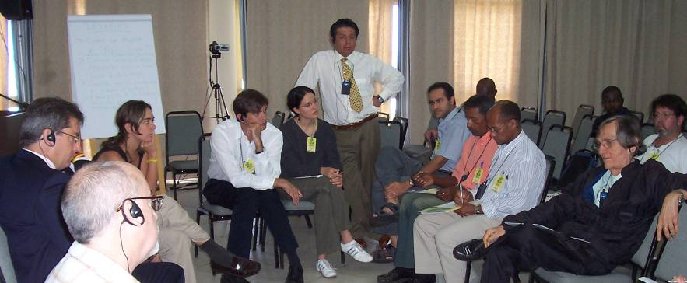

Participants

Name | E-mail | Position, Company | Adress
Aaron James Gunson | info@ajgunson.net | Mineral Process Engineer, Fluor Canada, CASM | 508-1318 Homer Street, Vancouver, Canada, V6A 6A7
Abdurramane Machon |  | Ministry of Mines | Mozambique
Albino Jesus da paixão |  | Covemar owner, CBPM | Rua Agostino estevão Neto, SN - Barragem, Ourolândia - Ba
Alfredo Nogueira |  | Provincial Director of Mineral Resources and Energy, Ministry of Mines | Mozambique
Amelia Willians | awillians4@worldbank.org | Language Program Assistant, The World Bank | 1818, H Street, N.W. Washington, USA, 20043
Amon Banda | amonbanda@yahoo.com | Gemstone Miner and Cutter, Ministry of Mines | Box 31969, Lusaka, Zambia
Ana Cristina Fraco Magalhães |  | President Assistant, CBPM | Brazil
André Almeida
Andrew Gunn | agg@bgs.ac.uk | Economic Geologist, British Geological Survey | Keyworth, Nottingham, United Kingdom, NG 12 5GG
Andrew Walsh | awalsh33@uwo.ca | Professor, University of Western Ontario | London, Canada
Antônio Araújo |  | Mayor of Ourolândia | Brazil
Antonio Pedro | apedro@uneca.org | Senior Economic Affairs Officer, United Nations Economic Commission for Africa | P.O. Box 3005, Addis Ababa, Ethiopia
Arnaldo Mota | ownaton@yahoo.com.br | Geologist, CBPM | 4th Avenida, 460 - Centro Administrativo da Bahia, Salvador, Brazil, 41745-000
Arnaldo Mota |  | GEMAC/ CBPM | Brazil
Aurenio Cipriano | aureniocipriano@hotmail.com | AEIMM - Associação dos Expostos e Intoxicados por Mercúrio | Rua Álvaro Paes Leme, n. 69 Parque Cocaia, São Paulo, Brazil, 04849-070
Bernadette Mwakacheya | bmwakacheya@yahoo.co.uk | Economist, Ministry of Mines and Mineral Development | box 31969, Lusaka, Zambia
Bernard Paansa | gmd@sr.net | Geologist in Exploration, Ministry of Natural Resources | Mr. J. Lachmonstraat 181, Paramaribo, Suriname
Bernhard Peregovich | peregovich@lycos.de | Mineralogist, NAEA-UFPA | Rua Augusto Correas, 1, Belem, Brazil, 66075-900
Bruno Martel Jantin | b.martel-jantin@brgm.fr | Geologist, BRGM | 3 Avenue Claude Guillemin, Orleans, France, 45100
Carlos Alberto Soares Ferreira |  | Artisan, CBPM | Rua Renato Simas Reis, 115 Centro - Campo Formoso -Ba
Carlos Sabino da Silva | sabino.numa@ig.com.br | Coordinator, CBPM | Rua Benjamim Constant, 60 - Centro, Jacobina - Ba
Catalina Cock Duque | ccock@epm.net.co | Social Policy Planner, Fundacion Amigos del Choco/ Oro Verde | Carrera 35 No. 7-80, Medellin, Colombia
Cesar Mosquera | mosquera@oit.org.pe | Mg Social Management, ILO | Las Flores 295, Lima, Peru
Charles Loots | cloots@anglogoldashanti.com | Enviromental specialist, Anglo Gold Ashanti | 11 Diagonal Street, Johannesburg, South Africa, 2107
Charles Tuvibidila | charleswilsont@yahoo.fr | Engineer, CEO, SAESSCAM, Ministry of Mines | 4th floor Gecamines Building, 30th juin Street
Chifumbe Chansa | mines@zamnet.zm | Mining Engineer, Ministry of Mines and Minerals Development | Lusaka, Zambia
Chris Lubangakene | lc_kene@hotmail.com | Mineral Dresser, Uganda Dept. of Geological Survey and Mines | Plot 21-29 Johnstone Road PO Box 9, Entebe Uganda
Christopher Sheldon | csheldon@worldbank.com | Social Economic Development, The World Bank | 1818 H Street, N.W. Washington, USA
Cristina Echavarria | crisechu@yahoo.com | Geologist, Association of Responsible Mining, Green Gold Corp
Cynthia Ramos | ramosc@oitbrasil.org.br | Programme Officer, OIT-IPEC | SEN, Lote 35, Organização Inter. Do Trabalho, Brasília, Brazil
Daniel Lafuente | d_lafuente@acelerate.com | Business Administrator, Sajama | Av. Hermano Siles, N 5225, La Paz, Bolivia, 730
Daniel Paiva Alves |  | Artisan, CBPM | Rua Canavieiras 131 - Centro, Potiraguá - Ba
Danilo Bocangel | daniloboc@medmin.org | Biologist, Gerente | Ascarrunz #2674, La Paz, Bolivia, 591
David Plath | david@cleangold.com | Scientist, Cleangold LLC | 3443 NW Port Ct, Licoln City, USA, 97367
David Stevens | david.stevens@unvienna.org | Programme Officer, UN Office for Outer Space Affairs | PO Box 500, Vienna Internationnal Centre, Wien, Austria, A-1040
Diosébio Santos da Silva |  | Artisan, CBPM | Rua Renato Simas, 77 - Centro - Campo Formoso - Ba
Edilene Barbosa Simplício |  | Project Coordinator, CBPM | Rua Jaime Vieira lima, 104 - Pau da lima, Salvador - Ba
Edmund Bugnosen | edbugnosen@ntlworld.com | Mining, Engineer, Bungnosen Minerals Engineering | 80a Belgrave Road, London, United Kingdom
Edson José luiz Barros de Souza |  | Technical Assistant, CBPM | Praça Freilino Grafilht, 42 - Centro - Filadéfia - Ba
Eduardo Azevedo |  | BellaRocha | Brazil
Eliel Souza dos Santos | ledesculturas@bol.com.br | Artisan, CBPM | Travessa Teixeira de Freitas
Emanuel da Silva Alencar |  | Administrator, CBPM | Carnaíba/ Pindobaçu - Ba
Esperança Bias |  | Minister, Ministry of Mineral Resources | Av. Fernao de Magalhaes No. 34, Maputo, Mozambique
Estelle Levin | elevin1@worldbank.org | Program Assistant, The World Bank | 1818 H Street, N.W, Washington, USA
Esther Kamara | estokay29@yahoo.com | Social Worker, Network Movement for Justice Development | Freetown, Sierra Leone
Ezekiel Dyke |  | General Secretary, National Mineworkers Union | Sierra Leone
Fátima Momade | fmomade@dnm.mz | National Director of mines, Ministry of Mines | Ministerio dos Recursos Minerais, Pr. 25 de Junho No. 380, Mozambique
Félix Gomes lins |  | Artisan, CBPM | Trav. Teixeira de Freitas, 130 - Centro - Campo Formoso - Ba
Felix Hruschka | felix.hruschka@gama-peru.org | Project Team Leader, Projekt-Consult Gmbh/SDC | Los Halcones 277, Lima, Peru
Florinaldo Souza dos Santos | garte5@hotmail.com | Artisan/ Administrator, CBPM | Av. Senhor do Bomfim, 89 - Centro - Campo Formoso - Ba
Florisvaldo Souza dos Santos | floriarte@bol.com.br | Artisan/ Administrator, CBPM | Av. Senhor do Bomfim, 89 - Centro - Campo Formoso - Ba
Fred Kyakonye | weraga@hotmail.com | Principal Inspector of mines, Uganda Dept. of Geological Survey and Mines | Plot 21-29 Johnstone Road PO Box 9, Entebe, Uganda
Freddy Pantoja Timaran | fpantoja@computronix.com.co | Mining Engineer, CORPONARINO | Francisco de la Villota, Pasto Colombia
Frederico Rossiter |  | GEPEM/ CBPM | Brazil
Gabriela Factor | gfactor@cedeconet.com.br | Enviromental Engineer, Carl Bro a/s | Camino a Ojo de Agua 849, Catamarca, Argentina
Gavin Hilson | hilsongm@cf.ac.uk | Lecturer, Cardiff University | School of City and Regional Planing, Glamorgan Building, Cardiff, United Kingdom
George Sheba | gshaba@zamnet.zm | Miner, Self Employed | Box 28048, Kitwe, Zambia
Geovan Lopes de Araújo |  | Miner, CBPM | Carnaíba/ Pindobaçu - Ba
Geraldino de Almeida Pereira Filho |  | President Assistant, CBPM | Brazil
Geraldino Pereira de Almeida Filho | geraldino@cbpm.com.br | CBPM | Bahia - CAB, Salvador, Brazil, 41745-000
Gilbero Amorim Carvalho |  | Miner, CBPM | Carnaíba/ Pindobaçu - Ba
Gilberto Souza da Visitação |  | Artisan, CBPM | Rua Gildásio Souza, 401 - Centro, Nova Fátima - Ba
Gildazio Amorim Carvalho |  | Miner, CBPM | Carnaíba/ Pindobaçu - Ba
Gillian Davis | bygad@comcast.net | Helth Educator, UNIDO | 2230 NE 12th Avenue, Portland, USA, 97212
Gislei Ferreira de Andrade | artesanatomineral@bol.com.br | Artisan, CBPM | Tv 1º de maio, 03 - CHESF - Paulo Afonso - Ba
Gislei Santos Oliveira |  | Artisan, CBPM | Av. Guanambi, 2490 - Centro - Vitória da Conquista - Ba
Gotthard Walser | gwalser@worldbank.org | Senior Mining Specialist, The World Bank | 1818 H Street, N.W. Washington, USA
Gracia Baião |  | Centro Gemológico da Bahia | Brazil
Guillermo Medina | guillermo.medina@gamma-peru.org | Geological Engineer, Proyecto GAMA | Los Halcones 277, Lima, Peru
Heledd Jenkins | jenkinsHM1@cardiff.ac.uk | Research Associate, The ESRC Centre for Business Relationships | 55 Park Place, Cardiff, United Kingdom, CF103AT
Hélio Azevedo |  | Program Coordinator PRISMA/ CBPM | Brazil
Henry Benavides |  | Instituto Euvaldo Lodi - IEL | Brazil
Hermínia Xavier | herminia_xav@yahoo.com.br | Manager, Ministry of Mines | Ministerio dos Recursos Minerais, Pr. 25 de Junho No. 380, Mozambique
Jack Satkoski | jackoski@televar.com | Exploration Mining Geologist, Cleangold LLC | 251 Baydrive, USA, 83860
Jaconias Saturnino de Jesus |  | owner, CBPM | Rua nova, SN - Centro, Ourolândia - Ba
Jean Francois Orru | jf.orru@brgm.fr | Socio-economist analyst, BRGM | 3 Avenue Calude Guillemin, Orleans, France, 45100
Jeane Souza dos Anjos |  | Artisan, CBPM | Rua Jaime Vieira lima, 104 - Pau da lima, Salvador - Ba
Jeff Davidson | jeffrey_davidson@yahoo.com | Engineer, Independent | 11519 Lockhart Place, Silverspring, USA
Jerry Ahadjie | jahadjie@yahoo.com | Geoscientist/Mining Engineer, Minerals Commission | P.O. Box M248, Accra, Ghana,
Jesamari Andrade | jesa2004@hotmail.com | Lawyer, Honduras Mining Direction | Boulevard Miraflores, Ave La FAO ed DEFOMIN, Tegucigalpa, Honduras
José Antonio Puppim de Oliveira | puppim@fgv.br | Fundação Getúlio Vargas | Praia de Botafogo, 190, sala 507, Rio de Janeiro, Brazil, 22250-900
José Carlos da Silva |  | Cooperative Director (CBPM) | Rua do Pará, 78, Jacobina-BA, Brazil
José Carlos Silva Santos |  | Artisan, CBPM | Av. Itabuna, 348 - Centro - Santa Cruz da Vitória - Ba
José Cícero Florentino da Silva |  | Pichoteiro, CBPM | Rua da Caixa, SN - Centro, Ourolândia - Ba
José de Oliveira Costa |  | Artisan, CBPM | Tv. Senhor do Bomfim, SN - Centro - Macaúbas - Ba
José Maria Souza | jmsouza@iec.pa.gov.br | Medical Doctor, Evandro Chagas Institute | Av. Almirante Barros, 492, Belém, Brazil, 66090-000
Juan Manuel Montes Hincapie | reddptal@udea.edu.co | Chemical Engineer PhD, University of Antioquia | Calle 67 No 53-108, Medelin, Colombia, 57/4
Kathia Romero | romerok@oit.org.pe | Antropologist, IPEC/ILO | Las Flores 275, Lima, Peru, lima14
Kennedy Liyungu | seismic@coppermet.zm | Geologist | box 341969, lusaka, Zambia
Kevin D'Souza | kdsouza@wardell-armstrong.com | Consulting Mining Engineer, Wardell Armstrong LLP | Lancaster Bldg, High Street, New Castle-under, United Kingdom
Ko Thie Chung Kwie Tsing |  | Geologist in Mine Inspection, Ministry of Natural Resources | Mr. J. Lanchmonstraat 181, Paramaribo, Suriname
Lantoniaina Rabenatoandro | mem.prsm@wanadoo.mg | Chief of Region of Vakinankaratra, Malagasy Government | Vila Tiko Mahafaly, Antsirabe, Madagascar, 112
Liliana Obregon | ipec@cable.net.co | Sociologist, OIT | Av. 82 #12-8 of.504, Bogota, Colombia
Lívia Vasconcelos |  | Press Assistant, CBPM | Brazil
Lothar Codfried | marcel_bridge@yahoo.com | Legal Officer, Ministry of Natural Resources | Melahierst 4, Paramaribo, Suriname, 597
Luciano de Andrade Ferreira | arteluc10@yahoo.com.br | Artisan, CBPM | Vila Pernambucana, 10 - Centro - Campo Formoso - Ba
Lucie Phillips | icphillips@ibi-usa.com | Economist, International Business Initiatives | 2200 Clarendon Blvd. Suite 1200, Arlington, USA
Marcelo Veiga | veiga@apsc.ubc.ca | Chief Technical Advisor, Unido | 6350, Stores rd., Vancouver, Canada, V6T1Z4
Marcia de carvalho Rocha |  | Superviser, CBPM | Rua Jaime Vieira lima, 104 - Pau da lima, Salvador - Ba
Marcio Pedroso | pedroso@acpo.org.br | ACPO | Rua Julio de Mesquita, 148 cj 203, Santos, Brazil
Marcos Nascimento Lopes |  | Finances Director, CBPM | Brazil
Maria Helena Rocha Lima | zcastilhos@cetem.gov.br | Researcher, CETEM, Center for Mineral Tecnology | Avenida Ipe, 900, Rio de Janeiro, Brazil, 21941590
Marjorie Cseko Nolasco | marjorie.nolasco@gmail.com | Geologist Professor, Universidade Estadual de Feira de Santana | Estrela do Sol, Qd. Z, casa 3, Salvador, Brazil, 41600-750
Martan Luiz Silva Costa |  | Artisan, CBPM | Rua Abílio Ferreira Souto SN - Alto da Colina, Potiraguá - Ba
Meredith Block | block@blacksmithinstitute.org | Administrator, The Blacksmith Institute | 2 Park Avenue, New york, Usa
Mike Burns | mburns@csir.co.za | Environmental Consultant, Concil for Scientific and Industrial Research (CSIR) | PO Box 320, Stellenbosch, South Africa, 7599
Mohammed Amate |  | Mining Engineer, Ministry of Solid Minerals | PMB 107, Abuja, Nigeria, 900001
Natalia Yakovleva | yacovlevan@cardiff.ac.uk | Research Associate, The ESRC Centre for Business Relationships | 55 Park Place, Cardiff, United Kingdom
Nelber Almeida dos Santos | nelberarte@bol.com.br | Artisan, CBPM | Praça João Saturnino, SN - Raulino Saturnino - Campo Formoso - Ba
Obiora Azubike | azubikeo2003@yahoo.co.uk | Deputy Project Coordinator, Ministy of Solid Minerals | PMB 107, Abuja, Nigeria, 900001
Olle Ostensso | olle.ostensson@unctad.co.uk | Chief of Section, Unctad | Palais des Nations 1211, Geneva 10, Switzerland
Patience Singo | patiencesingo@yahoo.co.uk | Mining Engineer, Goodlife Investments | Box 3767, Bulawayo, Zimbabwe
Patrick Schein | sptrading@wanadoo.fr | CEO, S&P Trading | 111, Avenue Victor Hugo, Paris, France, 75116
Paul Henney | pjhen@bgs.ac.uk | Geologist, BGS | Keyworth, Nottingham, United Kindom
Paulo Afonso Vecchi |  | Administrator, CBPM | Carnaíba/ Pindobaçu - Ba
Peter Hughes-Hallet | hughesh76@hotmail.com | Enviromental Engineer, Honduras Mining Direction | Boulevard Miraflores, Ave La FAO ed DEFOMIN, Tegucigalpa, Honduras
Rachel Pollack | pollackrachel@yahoo.com | Coordinator Enviromental Section, Ministry of Natural Resources | Mr. J. Lanchmonstraat 181, Paramaribo, Suriname
Remi Pelon | r.pelon@brgm.fr | Engineer, BRGM | 3 Avenue Claude Guillemin, Orleans, France, 45100
Rickford Vieira | rvieira@wwf.sr | Mining Engineer, World Wildlife Fund-Guianas | Gravenstraat 63, Paramaribo, Suriname
Rita Gabriela Arruda | ritagabriella@gmail.com | Student | Rua Gilberto Cardoso, 260/901, Rio de Janeiro, Brazil, 22430-070
Robert Charles Wightman | bioad@zamtel.zm | Miner, Self Employed | Ministry of Mines, Box 50450, Lusaka, Zambia
Rosa Maria Rodrigues Pereira |  | Artisan, CBPM | Rua João Nunes Reis, SN - Jacaré - Filadélfia - Ba
Rosimere Conceição dos Santos |  | Artisan, CBPM | Rua Jaime Vieira lima, 104 - Pau da lima, Salvador - Ba
Ruy Fonseca Lima | geraldino@cbpm.com.br | Geologist, CBPM | Bahia - CAB, Salvador, Brazil, 41745-000
Ruy Lima |  | Director, CBPM | Brazil
Sahr Nyaama | sahrnyaama@yahoo.com | Community Mobilization Officer, Management Systems International | Av. Julius Nyerere 938 7th floor, Maputo, Mozambique
Sakwiba Musiwa | smusiwa@yahoo.com | Geologist, Ministry of Mines and Minerals Development | box 31969, Lusaka, Zambia
Saleem Ali | saleem@alum.mit.edu | Professor, University of Vermont | 153 S. Prospect Street, Burlington, USA, 05401
Salvador Mondlane |  | Researcher, Eduardo Mondlane University | Av. Julius Nyerere 938 7th floor, Maputo, Mozambique
Sam Spiegel | samspiegel@gmail.com | Policy and Economics Analyst, UN Industrial Dev. Organization | 2085, Whyte Ave, Vancouver, Canada, V6J1B6
Shefa Siegel | shefa@shaw.ca | UN Advisor, UNIDO | 3503, W 1st Ave, Vancouver, Canada
Silvia Costa Rauen |  | Assistant of DAF/ CBPM | Brazil
Stephen Metcalf | metcalf@telus.net | Geologist, UNIDO | 2185, Yotk Ave, Vancouver, Canada
Sturaro Pereira Dias |  | Artisan, CBPM | Av. Guanambi, 2490 - Centro - Vitória da Conquista - Ba
Thomas Cushman | mem.prsm@wanadoo.mg | Gem Dealer Consultant, Allerton Cushman & co, PGRM | PO Box 918, Sun Valley, USA
Thomas Hentschel | thomas@medmin.org | Advisor, Projekt-Consult-Gnbh | Casillha 4679, La Paz, Bolivia
Thuthukani Mtshali | thuthukaniM@mintek.co.za | Mineral Economist, MINTEK | Private bag x3015, Randburg, South Africa, 2125
U. Linus Adie | uladie2001@yahoo.co.uk | Project Coordinator, Ministry of Solid Minerals | Nigeria
Usman Kamara | usmanboie@yahoo.com | Mining Engineer, Government of Sierra Leone | youyi Building, Freetown, Sierra Leone
Valmir Badaró |  | Manager of Banco do Brasil/ Agência de Pindobaçu | Brazil
Veronika Kohler | elevin1@worldbank.org | Consultant | 1818 H Street, N.W, Washington, USA
Victor Manuel Reinoso Rivas | amasucperu@yahoo.es | Artisanal Miner, Empresa Minera La Victoria S.A. | Lima, Peru
Victoria Nunez | Victoria.nunez@gama-peru.org | Economist, proyecto GAMA | Los Halcones 277, Lima, Peru
Walter Arcoverde
Zizete Nogueira |  | PRISMA/ CBPM | Brazil
Zuleca Castilhos | zcastilhos@cetem.gov.br | Researcher, CETEM, Center for Mineral Tecnology | Avenida Ipe, 900, Rio de Janeiro, Brazil, 21941590

Field Trips
Information about visited sites provided by Companhia Baiana de Pesquisa Mineral (CBPM)

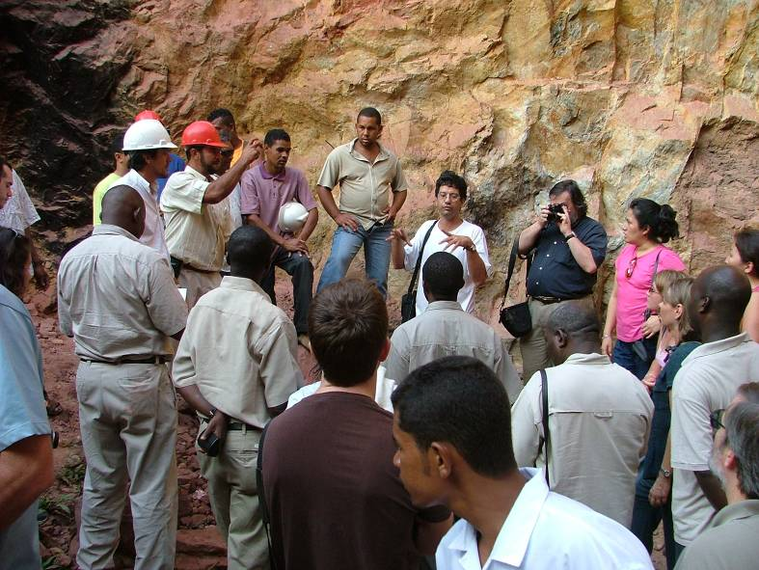

Jacobina Gold mines
The city of Jacobina is located on the western side of a mountain having the same name, in the northern region of the state of Bahia. The Jacobina mountain range is a remarkable landscape, with a belt of mountains having 170 km of extension, with an average width of 7 km and peaks that reach 1,200 meters of altitude.

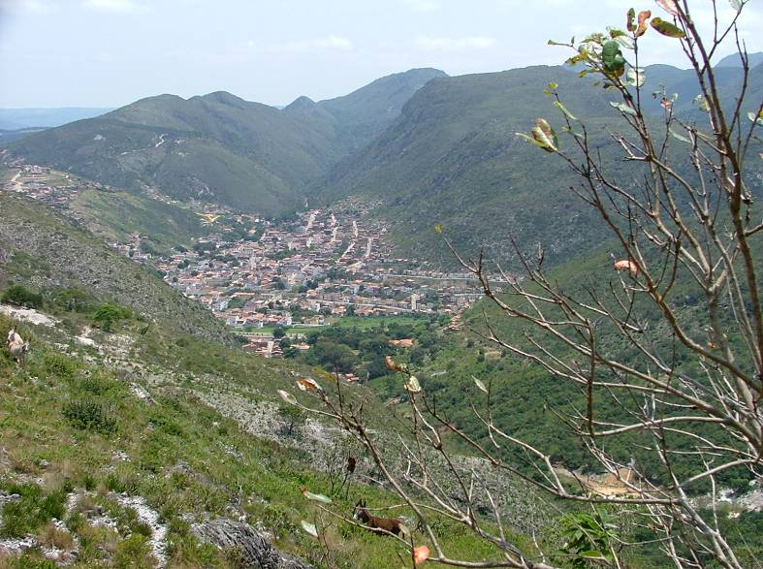
In these geological formations, the mineral resource most widely known is gold, accompanied by manganese, chromium, emerald, amethyst, uranium and barite. Gold was discovered in Jacobina, at the beginning of 18th century. Throughout the time from then until the current days the activity of prospectors has existed. In 1880, the Jacobina Mining Company began a small-mechanized mining operation with equipment imported from Europe, working until 1896. Other attempts of mechanization occurred during the decade of the 1950s in the twentieth Century.
Large-scale mining was started by the Anglo American (South African) company in 1977, in the south of Jacobina. This enterprise passed to William Resources (Canadian), was closed during some years and reopened this year by Desert Sun Mining (also Canadian), with a production of 2.4 tons per year.
Prospectors, numbering about 200 or 300, currently work in the region. Many of them work individually, using only rudimentary tools. Others use small hammer mills, using mercury for gold concentration, although they are aware that it is damaging to their health and that of others. Currently they are creating cooperatives that can benefit them in diverse aspects:
- To have greater opportunity for dialogue with governmental organizations and large mining companies;
- To obtain licenses and titles (mineral and environmental) that cost significant sums of money;
- Working in conjunction, they can acquire larger mills and use methods for concentration of gold, without using mercury;
- To sale the gold directly, in legal and safe ways, eliminating the middlemen (intermediaries), who can take up to 30% of the profits.

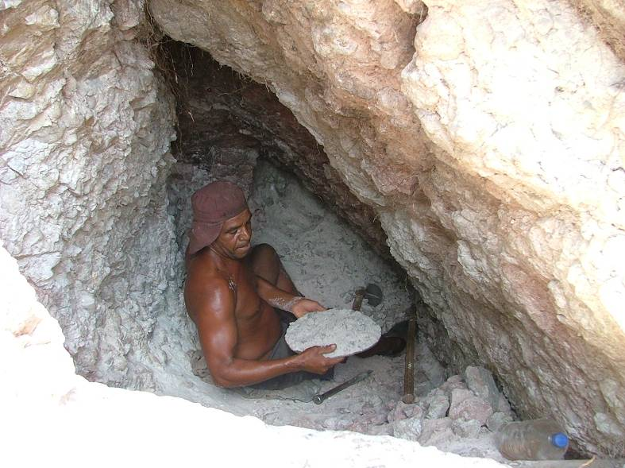

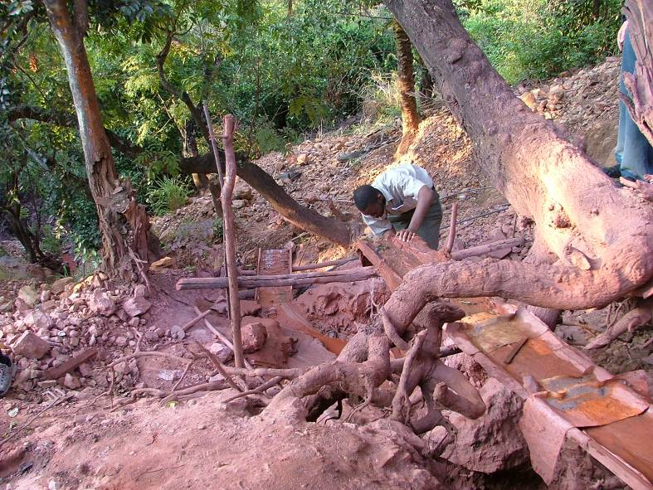

Carnaiba Emerald mines
The emerald occurs in pegmatites and has as an important by-product the molybdenite, a mineral that also occurs in pegmatites. It is the ore-mineral of the element molybdenum. The molybdenite and the emerald are mined in the same way. To separate the molybdenite from the ore, is used a method called flotation.

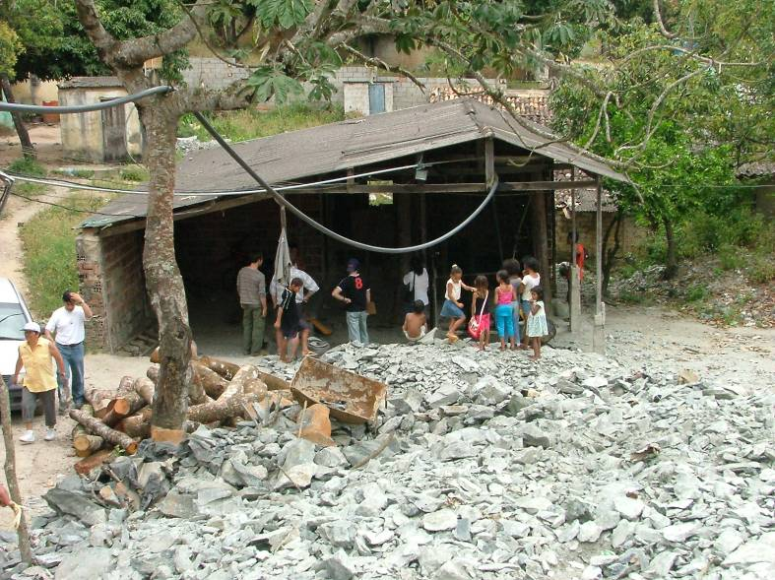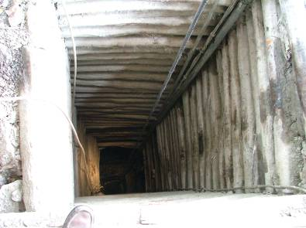
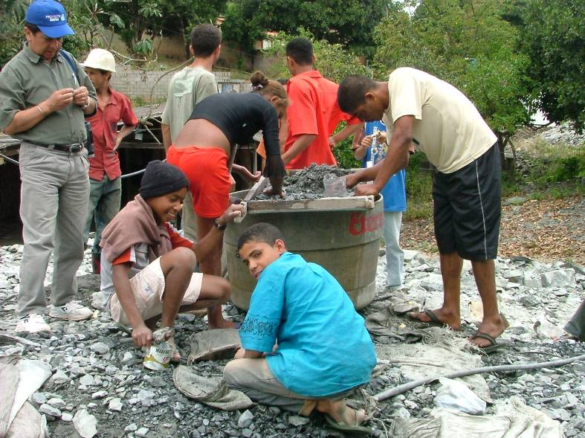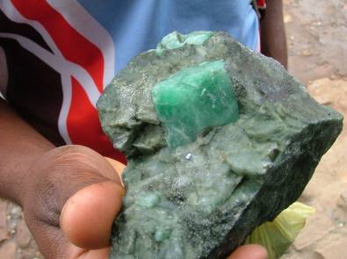
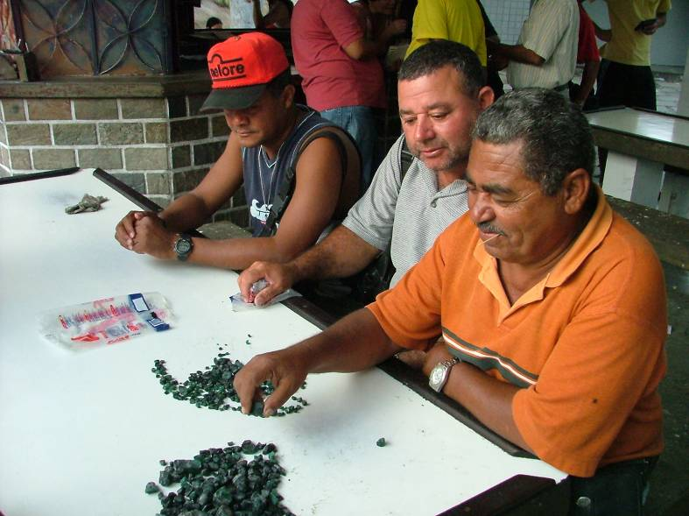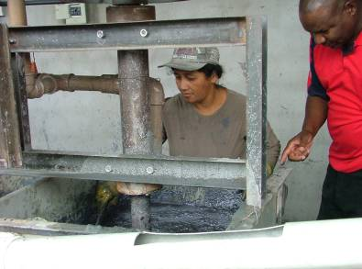

The milled ore is put in the flotation cell (“flotadeira”), and then are added some chemical reagents (pine oil and kerosene). The molybdenite floats with the foam produced and the foam is collected in fine sieves and dried on a zinc plate above a wooden fire.
Cost of excavation:
In the mines up to 70 meters deep in quartzite, the cost of excavation may reach US$ 500 to US$ 1000; for mines deeper than 70 meters there is a progressive increase of cost that may reach between US$ 1500 and US$ 2000 / meter.
Cost/profit:
As is impossible to preview the emerald concentration and quality there is necessity of adding value to the minerals through lapidary work, besides the production of molybdenum and mineral handicraft. Taking into account all this, the relation cost/profit is rather favourable. However, is needed a more technical evaluation of the cash flow, a procedure not usual in the garimpos.

EMERALD MINES FLOW SHEET

Vertical relationships
OWNER/INVESTOR
Financial support

GENERAL MANAGER
Technical operation of the mine

CHIEF OF PARTY
Coordinate the workers in the tunnels

INSPECTOR
Check the production on behalf of the mine owner or investor

Horizontal relationships from the mine front to the surface
CUTTER (“CORTADOR”)
Find and follow the productive veins, drill and blow up them, collect and check the minerals extracted =>

CUTTER HELPER
Supports the cutter in all his tasks =>

CLEANERS (“DESARROLHEIROS”)
Clean the mine front and fill the carts with the blown up ore =>

FILLER
Fill both carts and buckets made of old tires with ore =>

CARRIER (“CARREIRO”)
Transport the ore and dump to the “caçambeiros” =>

“CAÇAMBEIRO”
Transport ore and dump from the mine with the above buckets =>

“GUINCHEIRO”
Operate the winch to hoist personnel, equipment and ore up and down the mine =>

“GAMBIARRA”
General services in the mine =>

Licensing procedure:
As Carnaiba is a Garimpo Reserve, the owner of the surface terrain is the same of the subsoil. Under the administrative view point, there are no more formalities.
Role of the “quejilas”:
“Quejilas are people of low income, who make their living washing the dump of the mines after small stones. They are important social-economically, because their finds are immediately sold in place. They are considered as a good indicator of the mines production: the more “quejilas” in a mine entrance, higher is the production of that mine.

EMERALDS QUESTIONS AND ANSWERS

How the emeralds brought economic development?
The emeralds attracted much people to the garimpos and after them came traders, investors and because of the raise of population, some public services. With the improvement of the living conditions, the employments doubled or even tripled. However, there are enormous social shortcomings that need policies specifically directed towards the Garimpo Reserve. Additionally should be noted that the greatest benefits were gone to the neighbouring towns, as Campo Formoso. There, 70% of the emeralds trade depends on the Carnaiba mines.
How are the stones cut and polished?
The emeralds are classified and cut with a diamond saw. Then, the stones are shaped with an abrasive disk and finally polished with special disks.
How much is the profit?
In the stones suited for polishing, the value added is 70%.
How long takes the training of the lapidaries?
The lapidary courses in general last seven months; however, expert lapidaries say that they should be at least twelve months long.
How to establish a detail store?
Through one of the existing associations or cooperatives of the garimpo.
Where?
In a place where there are circulation of people, such as tourists; Pelourinho em Salvador, for example.
Why is better to trade expensive stones in the morning?
Because in the morning the natural light is perfect, so that the quality of the stone is better perceived.

Arenito Tombador (Tombador Sandstone)
A sedimentary stratified rock extracted manually using simple tools: as wedge, sculptor's hammer and handspikes. Small 2-3cm thick slabs are extracted, obeying the splitting surface of the rock, that is cut in rudimentary machines, equipped with two small disc saws, producing paving-tiles measuring 30X30 cm, 40x40 cm and 50 x 50 cm.
The rock’s beauty, with its rough aspect, and its sufficiently accessible price of R$6.00/m2 is adequate especially for covering of outdoor flooring and swimming pool areas, has already awakened the attention of Italian importers who are acquiring the material to commercialize in Europe.

Bege Bahia Marble
The Bege Bahia Marble is the only travertine marble in Brazil and the most consumed marble in the national market. With tone variations from yellowish-beige to lightly brown, it is currently the “top of fashion” material on the international fabricators.
Its official reserves reach more than 85 million cubic meters, sufficient for several centuries, with current production levels of 60,000 m3 per year.
The last publication, from 2005, with information from 2004, registered the existence in the region 28 quarries, of which 22 are mechanized and 6 manually operated. For processing there are 13 industries with 18 gangsaws for cutting the rough blocks into slabs. Five companies are specialized in polishing and five marble workshops.
The quarries have 4 technological levels:
- Quarry with high technology: only one has the ultimate machinery.
- Quarries with mixed technology: using diamond wire and helicoidal wire (old technology);
- Quarries with old technology: intensive use of helicoidal wire to extract blocks.
- Quarries with rudimentary technologies: manual extraction, utilizing a maximum of one helicoidal wire.
The processing has a great economic importance, because it increases value, along the lines of 3 to 4 times, generating a considerable number of jobs.
Currently the productive change directly employs 645 individuals.
The industries are divided into 3 technological levels:
- Industry with modern technology for cutting and polishing: diamond gangsaws, and automatic polishing machines.
- Industry with modern technology for cutting and/or old or rudimentary polishing technology;
- Industry with cutting equipment having antiquated technology, rudimentary polishing technology, old machinery at all.
The quarries tailings are still very little utilized. A small portion is cut down into smaller blocks to provide cut blocks to feed small Block cutters.

